**URBING CORRUPT PRACTICES AND UNETHICAL VALUES IN NIGERIAN TERTIARY INSTITUTIONS: THE INFORMATION COMMUNICATIONS TECHNOLOGIES (ICT) APPROACH**

**BY**

**PROFESSOR GODWIN ONU**

**RECTOR**

**FEDERAL POLYTECHNIC, OKO**

**ANAMBRA STATE**

**BEING A TEXT PAPER PRESENTED AT THE NATIONAL CONFERENCE ON TRANSPARENCY, ACCOUNTABILITY AND ETHICAL VALUES IN TERTIARY INSTITUTIONS FOR SUSTAINABLE DEVELOPMENT ORGANIZED BY THE INDEPENDENT CORRUPT PRACTICES AND OTHER RELATED OFFENCES COMMISSION (ICPC) ON THE 20TH AND 21ST OF MAY, 2014 AT LADI KWALI CONFERENCE CENTRE, SHERATON HOTELS AND TOWERS, ABUJA.**

Protocol

When I received the Commission’s letter requesting me to perform a dual function at this Conference: (i) attend the conference and (ii) serve as Resource person; I was extremely humbled for recognizing me amongst other qualified persons to perform this national assignment.

I feel greatly honoured to be one of the speakers/discussants at this important occasion, the National Conference on Transparency, Accountability and Ethical Values in Tertiary Institutions for Sustainable Development organized by the Independent Corrupt Practices and Other Related Offences Commission (ICPC). Given the theme of the Conference and the Commission’s intervention at tertiary institutions in the country, in my humble opinion, I decided we shall discuss today how to curb corrupt practices and unethical values in Nigeria's tertiary institutions using the information communications technologies approach. This is mainly because we are in the information age driven by information communications technologies (ICTs).

As a Chief Servant of one of the Federal Polytechnics in the country, where we and some of our sister institutions in the country have commenced the application of information communications technologies in curbing corrupt practices and unethical values, I wish to share our experiences, publicized them on a wider scale and buttressed how they could complement the efforts of the ICPC and traditional/conventional means designed to curb these monsters.

**INTRODUCTION**

As Nigerian struggles to tame the psychosocial beast known as corruption searchlight has been beamed at the behavior of public officials (civil servants, military and police personnel, elected officials etc.) and former public officials, contractors, business associates of public officials and families of public servants.

In today's presentation attention shall be focused on the education sector especially the polytechnic education. Ordinarily education is expected to have the capacity incorporate sustainable development values and practices into core activities of teaching and research, institutional management and operational systems. By sustainable development, we mean “Development which meets the needs of the current generation without compromising the ability of future generations to meet their needs” (UN, 1989). It is a mechanism through which the society generates the knowledge and skills required for its survival and sustenance. It enriches people's understanding of themselves and the world. It improves the quality of lives and leads to broad social benefits to individuals and society (Kazeem and Ige: 2010).

Overtime, unethical practices have affected the fortunes of our educational system in Nigeria, which (though controversial) is perhaps on its lowest ebb now. This seems to have affected adversely the ability of the sector to create and recreate itself and society. Since the sector is not isolated from the wider society it has to a large extent come under the adverse influence/s of its exigencies.

A lot of measures have been put in place to curb some monstrous developments in the sector especially in the tertiary institutions. This ranges from internal mechanisms inserted in the acts setting up the institutions, Schemes of service, Civil service rules, Procurement guidelines, Rule of conduct guiding examinations, establishment of governing councils and academic rules of engagement with host communities. There are also external measures of oversight from supervising and regulating bodies-Ministry of education, National Board for Technical education, Tertiary Education Trust Fund, National Universities Commission, the World Bank, The ICPC, the EFCC, the Code of Conduct Bureau, the State Security Services, the parliament, the offices of accountant General and Auditor General of Federation, the Bureau for Public Procurement and others. Recently, the Federal government directed the extension of Servicom to out institutions as well as Anti-Corruption Unit.

In spite of these, academic fraud, sharp practices, sexual harassment, unauthorized sales of handouts and books, extortion of various types are still common practices in our academic institutions. To a large extent, the sector remains one of the sanitized sectors in terms of financial management, due process because of caliber of people that head these institutions and members of governing councils. The major problem seem to center on the relationship between staff and students and to an extent students and fellow students. The other major issues is that of relationship between institutions and host communities as well as political interference in running of the institutions.

This paper attempts a paradigm shift from the conventional method of checking corrupt practices and ensuring good governance. It advocates digitizing processes of administration, teaching, learning and service delivery to complement the existing methods for optimum results. The digitalization process is done through the use of information and Communication Technology (ICT). Before going into how ICT can be used as a tool, it may be relevant to outline what constitutes corruption challenges in our tertiary institutions especially the Polytechnics.

Corrupt Practices in tertiary Institutions:

1. Extortion of students by staff
2. Underserved of award of scores after examination
3. Gratification
4. Indecent dressing
5. Political interference in management of Institutions
6. Godfatherism
7. Special requests for admission and employment
8. Value system and orientation on part of staff and students
9. Social media
10. Overcrowding during examinations and inadequate facilities for examinations
11. Channeling greed towards public office

**Other challenges facing the tertiary education sector**

1. Funding
2. Poor infrastructure
3. Incessant strike by labour unions
4. Host community interference in the management of tertiary institutions
5. Religious dichotomy
6. Ethnicity
7. We versus them dichotomy
8. Cultism.
9. Labour Unions and inherent abuses

The question posed by these vices and their accompanying challenges is how to solve them. There is no doubt that governments over the years have put a lot of tracking mechanisms in place to ensure that corruption is eliminated to the barest minimum to pave way for good governance in our tertiary education system.

One big question is whether these structures have been able to solve the problems of ethics and corruption in our tertiary educations system especially the Polytechnics. Again the big answer is NO.

It is in the light of this that we are proposing for national acceptance our experience at Federal Polytechnic Oko and how we have been able tackle some of these monsters through the use of information and communication Technology.

**The ICTs approach**

In this age of globalization, the importance of information and communication technology (ICT) to everybody generally, staff and students in particular cannot be overemphasized. This is true because ICTs facilitate quick and easy access to a wide range of information and information resources worldwide. In fact, it is now difficult to imagine a world without information technology. This equally suggests that anyone who is not ICT compliant is like someone who did not pass primary six.

Most if not all the areas of infractions identified at tertiary institutions in Nigeria could be addressed by the instrumentalities of information communications technologies as portrayed in the following analyses:

Sexual harassment and sale of academic handouts could be squarely addressed with flexible learning where learners are offered a variety of options for personalizing the learning experience based on their specific needs and preferences. To increase flexibility, therefore, means essentially to overcome obstacles emerging from the rigidity of traditional forms of education by enabling learners to select what is best for them with respect to key dimensions of learning (Collis & Moonen, 2001) through digital lectures and e-lectures that minimize contact between students and lectures.Furthermore, once produced, digital lectures may always be available on demand, increasing the cost/performance ratio of e-learning services. Digitization of learning material from books, academic journals and class notes makes learning easier for students because it provides them with possibilities of processing data. Instead of keeping huge piles of papers which makes it cumbersome to find the information the student might be looking for, digitalized material only requires one to search the key words and the information would be provided.

Setting of tough examination questions, admission syndicates and racketeering financial inducement and gratification, examination malpractices at the tertiary level of education and massive churn out of first class degrees could be checked through Computer-Based Testing (CBT) or e-examination. It is a method of administering tests in which the responses are electronically recorded, assessed, or both.

This is prided to have the capacity to eliminate examination malpractices and maladministration and engender a sense of meritocracy, responsibility and transparency. In addition to the examination itself, CBT takes care of other related activities that come in-between assessment such as test administration, setting questions and automated marking.

Examination malpractices, low capacity examination venues, inadequate invigilators, inadequate examination materials, omission of students results and human error(s) during the marking/grading process will be automatically eliminated if *e*- examination system is adopted. This also ensures that results are released almost immediately as students receive short message services (SMS) with their scores. This process makes no room for manipulation by some lecturers who use results as tools for witch hunting, money making and or exploitation of varied forms.

Since it is what we garbage in that we garbage out, Information and Communication Technology using e-governance process can be used to inject into tertiary institutions something better than garbage. These benefits have been corroborated by Blurton (2002), who opined that with the use of ICTs, tertiary institutions can improve the admission process by putting admission forms on-line and receiving completed forms online. They can also generate cards for entrance qualifying and semester examinations online. These procedures would speed up admission and examination processes and help in faster results' declaration.

Another benefit of CBT is the use of archival databank for the eventually admitted candidate.

With digitalized processes and procedures at tertiary institutions in the country:

1. Students’ records in school databases can be easily accessed, managed and updated as at when due.
2. Also computing and retrieving result of students for issuance of certificates would be carried out on real time basis.
3. More so, information about students would be accurate since it is usually updated every semester and the tracking of student files, cumulative assessments, scores of assignments as well as examinations would be recorded effectively and efficiently.
4. The databases would enable the students to check their performances at the end of each semester at will and on demand, such that they would have access to their results and comments from their lectures, including their grades.

Late commencement of lectures /non-completion of course outlines. Non-enforcement of class attendance for students, truancy and lateness to work by non-academic staff could be addressed by the introduction of **biometric devices.** Using a [biometric time and attendance system](http://www.intechsol-pr.com/its-enterprise.html) will allow more accurate check-in times and check-out times for staff and students. Devices such as [fingerprint and retinal scanners](http://www.intechsol-pr.com/products.html) will allow staff and students to clock in without the use of time cards, and it will also prevent the occurrence of time card fraud and “buddy punching”i.e. when one staff or student clocks in for another who is absent.

[**Biometric Time Clocks**](http://www.intechsol-pr.com/products.html)**(also known as Fingerprint Readers)** guarantees that staff and students must be present to clock in/out of work or lectures. With the touch of a finger or starring at the device, they can quickly log and verify their attendance, instantly improving the accuracy of attendance records.  
  
By eliminating ‘buddy punching,’ the institutions will notice a significant reduction in payroll and overhead costs and a subsequent increase in staff and lecturers’ productivity. In addition, [**Biometric Time Clocks**](http://www.intechsol-pr.com/biopad.html) can bring extra security to the institutions by ensuring that ghost workers and truants impostors cannot force their way onsite.  
  
**Time and Attendance Software:** Using a time and attendance software will allow for more accurate monitoring of staff and students check-in and check-out times. Software such as TimeWellScheduled will allow the institutions to integrate various punch clock hardware (ex. YubiKeys, swipe cards, biometric devices, etc.). Institutions payroll and attendance processing will also become much easier and more accurate by allowing it to automatically export work times into payroll software such as QuickBooks and Simply Accounting.  Time and attendance software will help reduce the amount of time spent on processing and will eliminate errors that could be made with manual processing.

Some staff and students print fake receipts, which they use in collecting school fees, and some unsuspecting students are usually discovered by the audit department. Automation of payment and verification of payment system tackles this kind of fraud.

Commercialization of intellectual property, plagiarism and sale of academic handouts could be checked and plugged with the use of plagiarism detection software and approaches like Fingerprinting, String Matching, Bag of Words, Citation analysis and Stylometry.

Social media as an anti-corruption tool is gaining more acceptance among the youth as more video-clips catching public officers in acts of corruption have been uploaded to YouTube and popular (I took bribe) sites e.g. ***egunje*** which have led to arrests and exposure.

In summary, in the modern information technology age, it has become imperative for all institutions globally to be computer technology compliant with digitalized processes and procedures in respect of admissions, enrolment and registration of courses, examination administration, award of degrees and graduation of students, teaching and learning services and facilities, appointments, promotion and discipline of staff, departmental administration and faculty governance, contracts awards, management of funds, research and research administration.

**Other forms of corrupt practices in tertiary institutions**

In tertiary institutions, corruption centers more in the relationship between students and staff. The staff are made up of academic and non-academic. For the academic staff, the most common form of corruption is driven by examinations, their conduct and outcomes. It is the outcome of these examinations that we use to measure the quality and performance of the students. There are other corrupt cases and areas but when we talk of corruption in tertiary education attention is quickly drawn to the ones arising during an interaction between students and teaching staff in both admission process, conduct of examinations and their results-the bloated emphasis on examination malpractice. This is because, whether we like it or not, if students are well taught, examinations properly conducted and graded in line with established rules of merit, the products of such a system will be beneficial to the society. Of course, examination malpractice is the most regular form of corruption in our tertiary institutions.

Examination malpractice is not limited to the time and place examination is taking place. There are pre- examination, examination and post examination malpractices.

In pre-examination malpractices, candidates knowing their ability offer to give something (cash or kind) to somebody (examiner, messenger, typist, examination officer, invigilator, or head of department) so that examination materials could be released to them before hand (leakage), they then study the materials with the view to memorize answers to the questions raised in the examination question they had access to.

During examinations, materials which candidates feel could assist them answer the questions could be brought in. Candidates could also collude by discussing or passing materials among themselves with a view to copying from each other.

Other forms of examination malpractice during examination could be impersonation where somebody writes an examination for another, assistance from invigilators and supervisors.

Post examination malpractice includes such activities after examination as a supervisor leaving the envelope containing examination scripts open on previous arrangement, so that submission of script(s) written outside the hall could be included in the envelope before sealing and submitting it to the examination body. Substitution is another method of post examination malpractice.

Furthermore, post examination malpractice includes candidates tracing their paper to the marking centre. Some examiners also could trace the candidate if they know how influential the parents of such a candidate are. Some candidates especially girls enclose money and photographs describing how they could be traced in case their papers happen to be handled by men considered to be moral perverts. Some include ready-made answers in small waterproof papers and put in their mouth and warm their mouth as they are chewing a gum, some hide such papers inside their cloths or scribble on their laps with purpose of transcribing them into answer scripts. What we call 'omokirikiri' is hidden in any part of the body as extraneous material which are often relevant to the examination.

Post-examination malpractice could take the form of lobbying the examiners by begging and sending close friends and senior colleagues to the examiner to be lenient while marking. Some lecturers who are charged with the responsibility of computing scores for reasons best known to them could also change marks. Some parents and even husbands send messages and make phone calls or even visit to lobby for marks for their wards.

In terms of supervision of candidate’s projects, thesis or dissertations, a lot go into it. Some lecturers reluctantly accept financilly poor students and will prefer candidates whose parents are rich. This is most common with undergraduate students who will prefer to use money to buy their way through. Because of lack of accurate data, projects which have been written by more serious students in other Universities or colleges are obtained and recopied, and with connivance of the lecturer, is submitted and accepted and high marks awarded.

For the non-teaching staff, the story is that of extortion from students. Those newly admitted are welcomed into the process during their registration processes. As newly admitted students, they are unsuspecting and are oriented into culture of corruption.

Assessment of students projects follow a similar line. Many teaching staff do not even know what to look out for while reading students projects. Some students pay huge sums of money to have their projects topics approved. During the time of submission some still pay for the projects to be accepted. Some candidates are admitted into these programmes when actually they know that they do not have the time to undergo the rigors of the programme. Such candidates connive; pay huge sums of money to get thesis written for them. All they need is the title without the content.

There is also corruption in appraisal, assessment and promotion of staff. In some institutions, lecturers going for Chief Lecturer position, pay and submit their publications to their preferred external assessor. These preferred external assessors could be either their friends, or someone who passed through such corrupt method to become either a professor or Chief Lecturer and who will not see anything wrong in the process. Scholars who are known to pay attention to details and raise critical issues while examining thesis are often avoided. Some Vice-Chancellors use appraisal and assessment to settle scores, rewards and punishment. A situation where report of assessment is not published creates room for some Vice-Chancellors to even pronounce some people as professors even when they are not qualified or someone could not have been assessed at all.

**The federal Polytechnic Oko Experience**

In talking about Federal Polytechnic Oko experience, it is important to note that issues of ethics and values are to a large extent, environmentally driven. The Federal Polytechnic Oko like many other institutions in Nigerian had its own peculiar history of dilapidation and corruption in all its hydra-headed versions. Peculiarities of an environment could determine the nature of corrupt practices that thrive thereon.

The first major step taken at OKO is to do away with traditional pencil and paper examinations.

Traditional (pencil, pen and paper) examination method has been one of the major banes of re-building quality education in Nigeria

Traditional examination means formal timed examination papers to which students respond in the form of written (essay-style) answers to a limited choice of previously unseen examination questions, set in advance and answered in examination centres where invigilators (examination supervisors) prevent communication between students and prohibit the use of notes or other revision aids.

Traditional examination is therefore distinguished from multiple-choice quizzes, course work, project-based work, peer review and open-book examinations, amongst other styles of assessment. Its working purely for marks or grades can be an indication of a cynical and purely strategic approach to assessment. It frequently enables students to evade some of the more serious deeper demands of their course and still pass.

**Challenges of traditional examination method**

The paper and pen (manual) method of writing examination, which has been in existence for decades, is being done away at Oko because of the problems usually experienced. These include:

1. Tedious processes as the examination will be conducted and marked manually;
2. Examination venue capacity constraints;
3. Lack of comfort for examination candidates;
4. Examination malpractices;
5. Cost implication of printing examination materials;
6. Human error,
7. Cost of conduct of the examination on the part of the institutions including honoraria for invigilators, coordinators, markers collators and other allied staff;
8. Subjective scoring and plausible manipulation of results: sorting of various scales and dimensions, orchestrated sexual harassment and distraction from both lecturers and female students owing to unnecessary relationships of tin-god position of lecturers;
9. Late release of results and missing grades;
10. Widespread corruption and indiscipline amongst both staff and students resulting in very poor attitude to teaching and learning; etc

**Computer based examinations as used in Federal Polytechnic Oko**

Harding and Raikes (2000), argued that new styles of learning have an exciting image in the world of ICT –led innovations, but assessment usually fails to raise enthusiasm. Assessment needs to be taken as a very vital component of the educational process because one of the challenges facing educational institutions today is the conduct of examinations resulting in valid and reliable scores.

Federal Polytechnic Oko commenced the use of computers in semester examinations without undermining the practical content of Polytechnic Education. It is the first Polytechnic in Nigeria to use computer based test to examine close to 40,000.00 candidates during Post UTME examinations which lasted for 7days without any missing results.

The Polytechnic kick-started the use of CBT examination method with the department of Public Administration at the first semester examination of 2012/2013 session; in spite of the teething challenges, it was a huge success that has been applauded by every positive minded persons. The students were taken through a thorough process of orientation and training where they were taught the use of the mouse and steps to accessing the interface that leads to the CBT examination questions and its procedures. Later on, bio-data and other details of the students and their sponsors were collected and uploaded onto the databank.

During the examination, every student was faced with a computer. All questions were submitted in soft copies in the morning of the examination. Questions were not submitted earlier to avoid leakages. Questions were juggled to avoid peeping and timed. Upon entering of bio-data and registration number, the questions rolled out and the student started answering. When the time remained five minutes, it alerted the candidates by counting down. At the count of zero, the system bed the candidate bye and thanked him or her for attempting the examination. The candidate then left the hall. In the next 30minutes, the candidates got the result alert in their phones and e-mail. The same alert went to the phone of their sponsors. At the end of every day, the candidates knew all that he or she scored in the examinations taken for that day. The day all examinations ended, the candidates got all the results including the sponsors.

The students of the Department and their guardians/sponsors for the first time received their results and those of their wards in their phones and emails few days after the exams. It was a system where lecturers graded and submitted continuous assessments scores of their students and submitted same to the Department along with their examination questions two weeks before the main examinations. Then, at the end of each examination, the computation of the continuous assessment scores (30%) were computed electronically with the students’ scores in the examination (70%) to make 100%, sent to the Departments for lecturers to confirm and the Academic Board to approve and subsequently uploaded onto the Polytechnic website at [www.federalpoloko.edu.ng](http://www.federalpoloko.edu.ng)

The students log in at the website when he has paid all relevant and requisite fees to access and print out their results irrespective of time and space without having physical contacts with lecturers or heads of department to release results.

**The merits of CBT**

1. CBT guarantees efficiency in examination delivery, administration and scoring. It far surpasses the traditional manual paper based assessments as the manual efforts of human hands are replaced by the many times more efficient processing power of the computer.
2. It also reduces the need for resources for many elements of the testing lifecycle such as printing and storing of paper, requirements of more invigilators to distribute and collect question papers and answer sheets.
3. Also, CBT ensures that results are released almost immediately as students receive short message services (SMS) with their scores. No room for lecturers who use results as tools of witch hunting, money making machines and or exploitation of varied forms.
4. Studies have shown that large class size in various higher institutions is inimical to learning but with constant continuous assessments and feedback better learning outcomes will be achieved. The problem is that it is difficult to have constant continuous assessments in large classes under PPT. CBT makes assessment and instant feedback possible and delivers better learning outcomes.
5. It will eliminate examination malpractices and maladministration and engender a sense of meritocracy, responsibility and transparency. These are some of the benefits that CBT will bring to our higher institutions when this innovation is introduced.
6. Discoveries reveal that CBT and its related forms of digitalization of teaching and learning is capable of facilitating dedication and effective teaching and learning since the lecturers will invariably be compelled to teaching the entire contents of their course requirements in order to generate the required number of questions especially in objective oriented CBT question format while students on their will read in-between-the lines to scale through.
7. In addition to the examination itself, CBT takes care of other related activities that interact with the assessment such as test administration, setting questions and automated marking.
8. Examination malpractices, low capacity examination venues, inadequate invigilators, inadequate examination materials, omission of students results and human error(s) during the marking/grading process will be automatically eliminated following the adoption of this *e*- examination system. The cost implication of conducting a mass-driven examination will become drastically and significantly reduced as there will be no need to print questions or answer booklets anymore.
9. The objectivity and security of the testing and the test items are important steps to eliminating examination malpractices, and improving admission and examination processes in the Nigerian higher education system. These benefits have been corroborated by Blurton (2002), who opined that with the use of ICTs, universities can improve the admission process by putting admission forms on-line and receiving completed forms online. They can also generate cards for entrance qualifying and semester examinations online. These procedures would speed up admission and examination processes and help in faster results' declaration. Another benefit of CBT is the use of archival databank for the eventually admitted candidates.

Below are pictures of Petroleum Development Trust Fund (PDTF) ICT/E-Examination Centre where Public Administration department students did their first semester CBT examination.



Petroleum Development Trust Fund (PDTF) ICT/E-Examination Centre

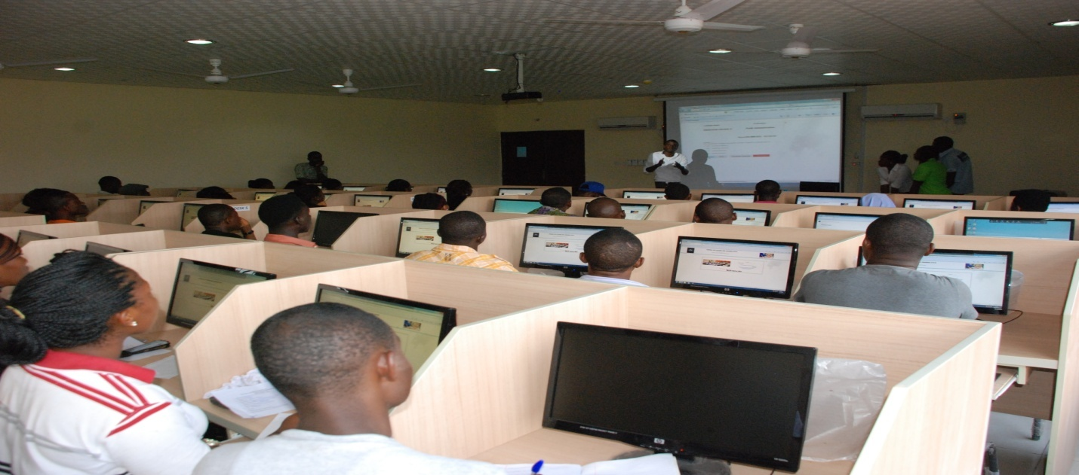

A cross section of the students in the PTDF ICT/E-Examination Centre

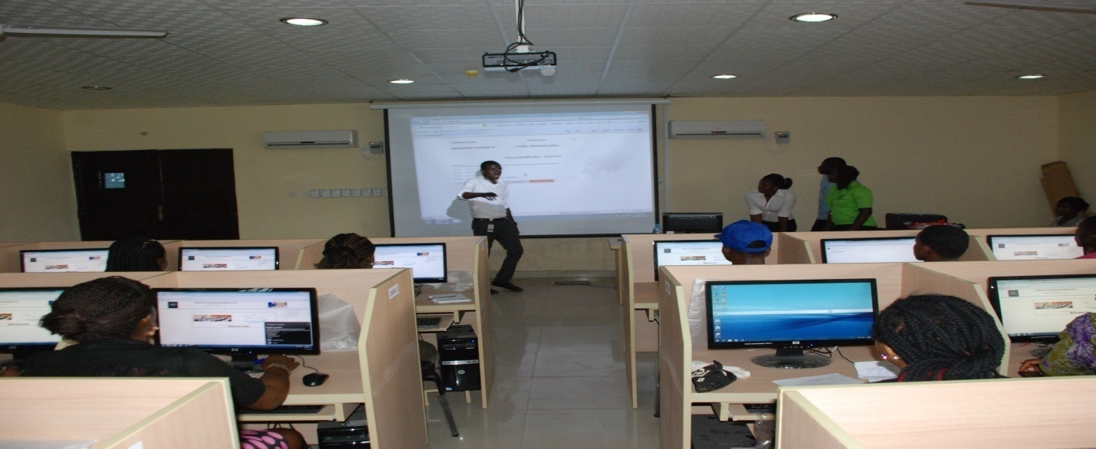

A section of students undergoing orientation course on how to do CBT

examinations in one of the halls.

**Post Unified Matriculation Examination (PUTME)**

The Polytechnic conducted its Post Unified Matriculation Examination (PUTME) examination for prospective candidates into the institution for 2013/2014 academic session through CBT.

Below are pictures of prospective candidates for admission into the Polytechnic during the CBT PUTME:

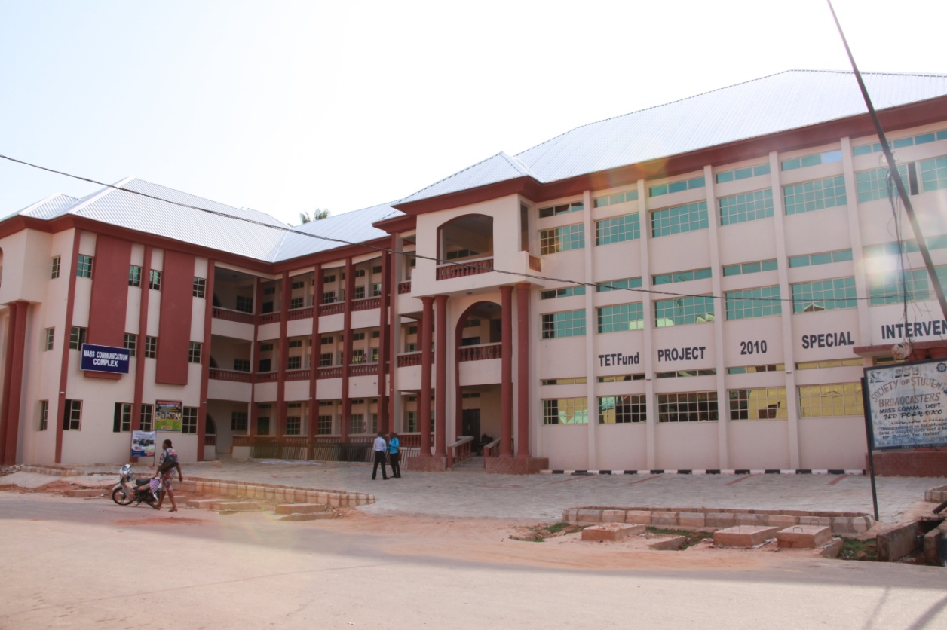

New Mass Communication Complex (**Tetfund** **Special Intervention**) that houses one of the Polytechnic Electronic Examination Centres at the moment

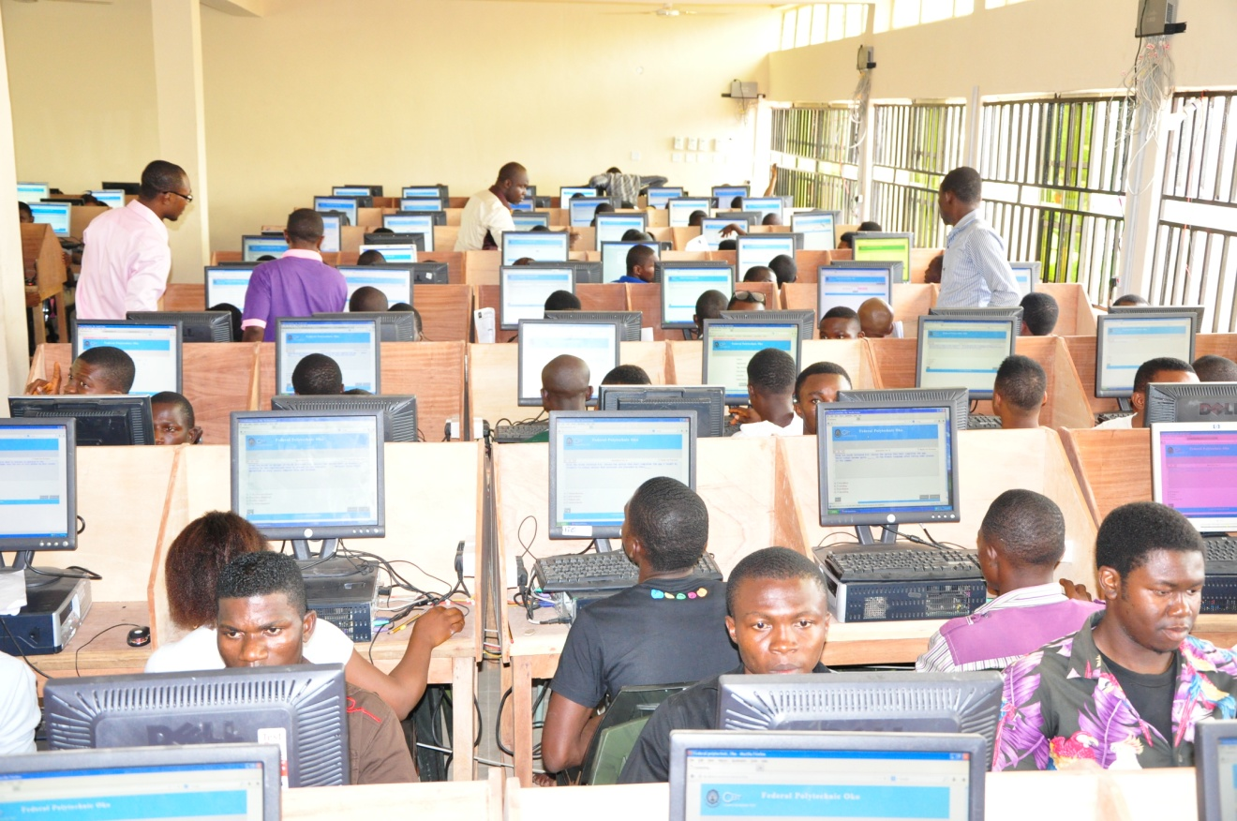**Prospective candidates for admission into the Polytechnic during the Post Unified Tertiary Matriculation Examination (PUTME)**

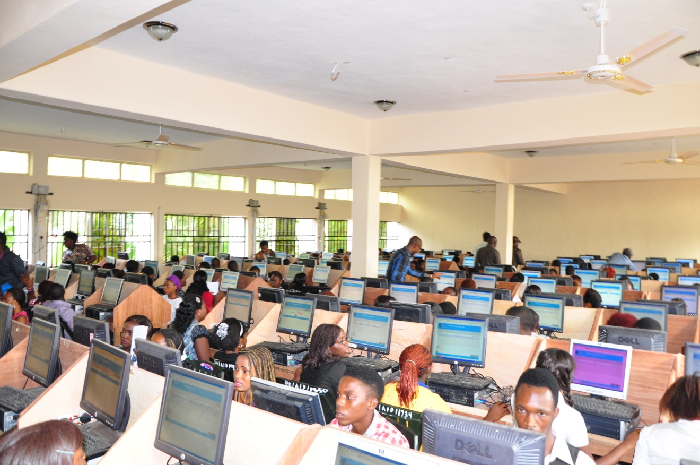

**Prospective candidates for admission into the Polytechnic during the Post Unified Tertiary Matriculation Examination (PUTME)**

**Some institutions that have adopted CBT partially or fully in Nigeria to our knowledge**

University of Ilorin, Kwara State

National Open University of Nigeria (NOUN)

Federal University of Technology, Minna

Federal University of Technology, Akure

University of Lagos, Lagos State

University of Agriculture, Makurdi

University of Maiduguri, Borno State

University of Ibadan, Oyo State

University of Nigeria, Nsukka

Covenant University, Ota

Federal Polytechnic, Oko

Joint Admission and Matriculation Board (JAMB)

**Recommendations as conclusion**

In view of the potential of CBT to usher in a credible examination regime and considering the modest success recorded at Federal Polytechnic, Oko with the use of CBT and its related approaches, I recommend the setting up of a National Committee to work out modalities and framework for the adoption of computer based testing (CBT) method of examination in all schools, colleges, polytechnics and universities in Nigeria as a panacea to examination malpractice and re-building quality education in Nigeria. It is further recommended that a national policy on Information Communication Technology and Computer-Based Test (ICT-CBT) method of teaching-learning-examination management and administration be developed to provide ICTs in tertiary institutions for improved standard of education.

**Conclusion**

Even though it might be expensive to install ICT technology, it could be used with almost zero marginal cost. ICT has also improved the quality of tertiary education because it provides new innovative methods of interaction and sharing of information. To benefit from the numerous opportunities offered by the adoption and use of ICT in carrying out tertiary institution’s functions, institutions must be e-ready.

**References**

Balogun J.O.( 1999). Examination malpractices and the Nigeria society. The Jos

Journal of education, 4(1), 110-116.

Bull, J. (1999). Computer – Assisted Assessment: Impact on Higher Education

Institutions. *Educational* *Technology & Society*, 2(3). Retrieved December

05, 2004 from <http://ifets.ieee.org/periodicals>

Harding R. & Raikes, N. (2000). ICT in assessment and learning: The evolving

role of an external examination board.

Hauwa, A. (2011). The nature and characteristics of examination malpractices among

Nigerian tertiary institutions. Retrieved January 7, 2014 from

[http://](http://              dietwithhauwa.blogspot.com/2011/06/nature-and-characteristics-of.html)

[dietwithhauwa.blogspot.com/2011/06/nature-and-characteristics-of.html](http://              dietwithhauwa.blogspot.com/2011/06/nature-and-characteristics-of.html)

Hornby. AS (1995). Oxford Advanced learner’s Dictionary. 5th ed. Oxford: Oxford

University Press.

Jamil, M, Tariq, R. H and Shami, P. A. (2012). Computer-based versus paper

based examinations: Perceptions of university teachers. The Turkish Online

Journal of Educational Technology, October, Volume 11, Issue 4

Maduka, C. (1993). Examination Malpractice: Causes, Implications and

Remedies. Benin City: Amik Press.

Makoju, G. E. A, Adewale, I, Nwangwu, R, and Shuaibu, M. J. (2004). Examination

Malpractice: Federal Republic of Nigeria/Development Partners. Nigeria

Education Sector Analysis.

McKenna, C. (2001). Introducing Computers into Assessment Process: What is the

Impact Upon Academic Practice? Paper Presented at Higher Education

Close Up Conference 2, Lancaster University, 16 – 18 July. Retrieved

November 4, 2004 from

[http://leeds.ac.uk/educol/documents/](http://leeds.ac.uk/educol/documents/                  00001805.html)

[00001805.html](http://leeds.ac.uk/educol/documents/                  00001805.html)

Uysal, O. and Kuzu, A. (2009). A Thesis Proposal: Quality Standards of Online

Higher Education in Turkey. Internationalization and the Role of University

Networks. Proceedings of the 2009 EMUNI Conference on Higher

Education and Research, Potorož, Slovenia, 25 – 26 September. Retrieved

December 25, 2010 from

[http://www.emuni.si/Files//Denis/Conferences/](http://www.emuni.si/Files//Denis/Conferences/                  EMUNI_HER/Proceedings/Papers/48.pdf)

[EMUNI\_HER/Proceedings/Papers/48.pdf](http://www.emuni.si/Files//Denis/Conferences/                  EMUNI_HER/Proceedings/Papers/48.pdf)

UN (United Nations) (1987), Our Common Future, Oxford University Press, Oxford.

Wikipedia Encyclopedia (2012). Computer-based assessment. Retrieved on

November 25 2011 from

[http://en.wikipedia.org/wiki/Computer-](http://en.wikipedia.org/wiki/Computer-                   based_assessment)

[based assessment](http://en.wikipedia.org/wiki/Computer-                   based_assessment)