SOME ABBREVIATIONS AND THEIR MEANINGS
ABBREVIATIONS | MEANING
AML | Anti-Money Laundering
CEPTI | Constituency and Executive Projects Initiative
CPOROA | Corrupt Practices and Other Related Offences Act 2000
CRA | Corruption Risk Assessment
CSOs | Civil Society Organizations
EFCC | Economic and Financial Crimes Commission
EICS | Ethics and Integrity Compliance Scorecard
EU | European Union
FEC | Federal Executive Council
IATT | Inter-Agency Task Team
ICPC | Independent Corrupt Practices and Other Related Offences Commission
JAMB | Joint Admissions and Matriculations Board
MDAs | Ministries, Departments and Agencies
NABTEB | National Business and Technical Eexaminations Board
NACC | National Anti-Corruption Coalition
NAD | National Anti-Corruption Debating Competition
NAPPS | National Association of Proprietors of Private Schools
NAPTIP | National Agency for the Prohibition of Trafficking in Persons
NEIP | National Ethics and Integrity Policy
NSIO | National Social Investment Office
NURTW | National Union of Road Transport Workers
OSGF | Office of the Secretary to the Government of the Federation
PSC | Project Steering Committee
RTEAN | Road Transport Employers Association of Nigeria
SAC | Students Anti-Corruption Club
SAP | Strategic Action Plan
SAV | Students Anti-Corruption Vanguard
SCUML | Special Control Unit Against Money Laundering
SDGs | Sustainable Development Goals
SIP | Social Investment Programmes
SSR | Systems Study and Review
SSRM | System Study and Review Manual
TUGAR | Technical Unit on Government and Anti -Corruption Reforms
UBEC | Universal Basic Education Commission
UNCAC | United Nations Convention Against Corruption
UNODC | United Nations Office on Drugs and Crimes
WAEC | West African Examinations Council

ORGANOGRAM OF THE INDEPENDENT CORRUPT PRACTICES AND OTHER RELATED OFFENCES COMMISSION

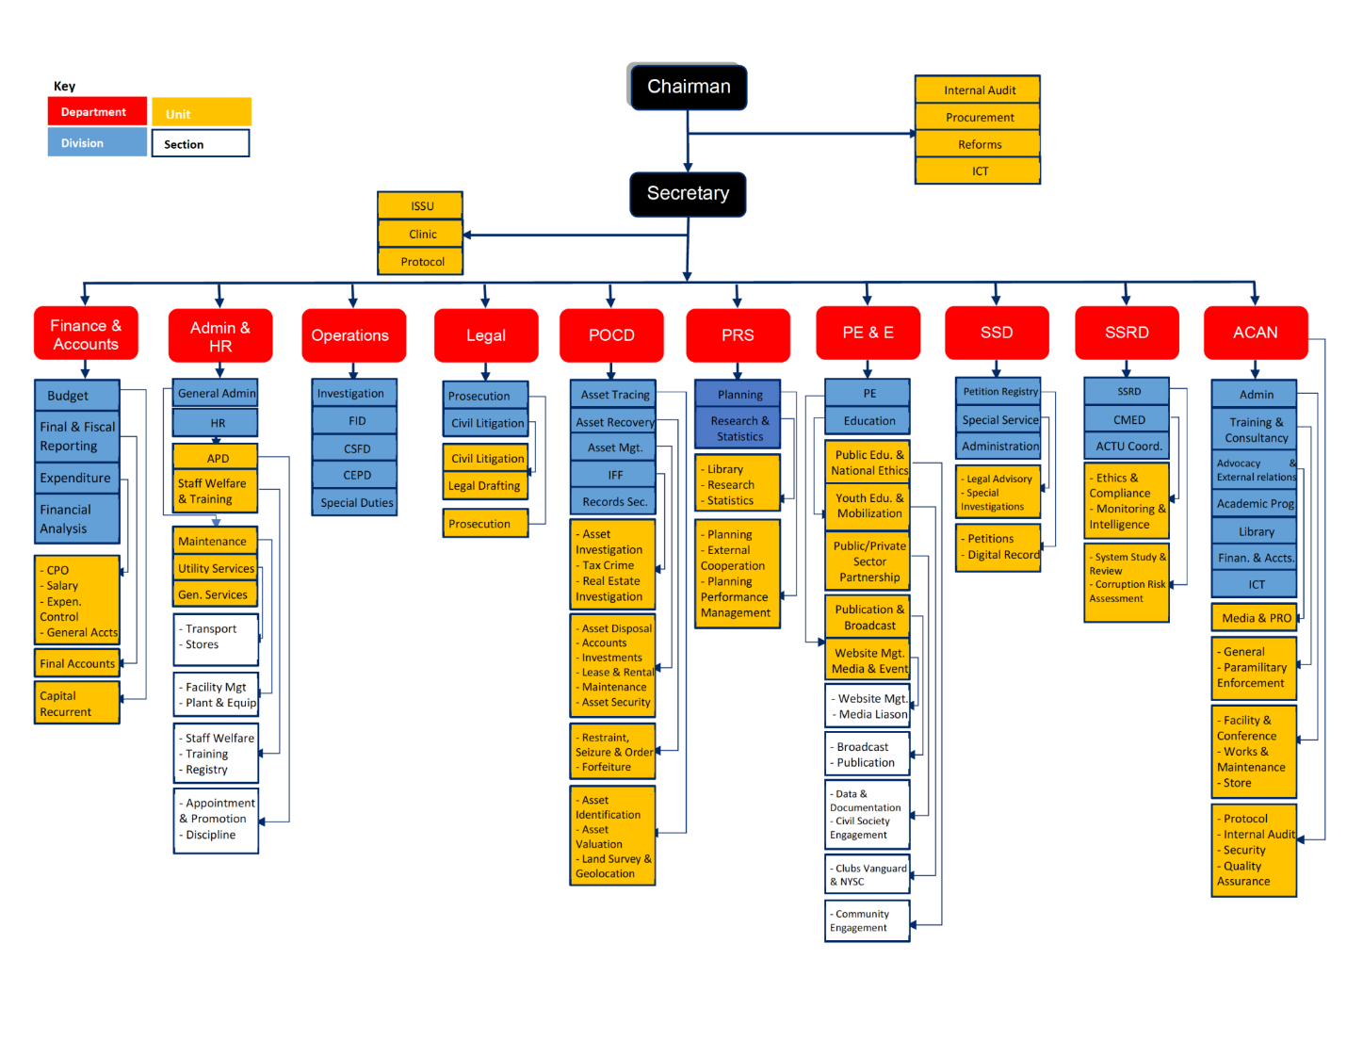
BRIEF HISTORY OF THE COMMISSION
The Independent Corrupt Practices and Other Related Offences Commission (ICPC) was established by the enactment of the Corrupt Practices and Other Related Offences Act (CPOROA) 2000, which was passed into law on the 13th of June 2000. Thereafter, the Commission was inaugurated on the 29th of September 2000.
The core mandates of the Commission are the enforcement of anti-corruption laws, enthronement of corruption-free practices and procedures in public organizations and education of the public on the ills of corruption with a view to enlisting their support through mass mobilization.
The giant stride in the establishment of the Commission came on the heels of the democratic administration of President Olusegun Obasanjo.
In pursuant of its mandate, the Commission has taken the fight against corruption to every sector of the economy and all levels of governance.
The Strategic Action Plan, 2019 – 2023, operationally came to an end in the year preceding the period under review, paving way for the development of a new plan. The new plan would methodically guide the Commission towards achieving its clearly defined goals and objectives between 2024 and 2028.
The reporting year was also quite significant as it marked the one-year anniversary of the Chairman of the Commission. On 17 October, 2023, the President and Commander-in-Chief of the armed forces of the Federal Republic of Nigeria, Senator Bola Ahmed Tinubu, GCFR, appointed a new Chairman as well as a Secretary for the Commission. Dr. Musa Aliyu Adamu, SAN was appointed as the 5th substantive Chairman of the Commission while Mr. Clifford Okwudiri Oparaodu, Esq. DSSR was appointed Secretary to the Commission. These gentlemen were both inaugurated on 13 December 2023, setting the pace for events that would unfold in the course of the year under review.

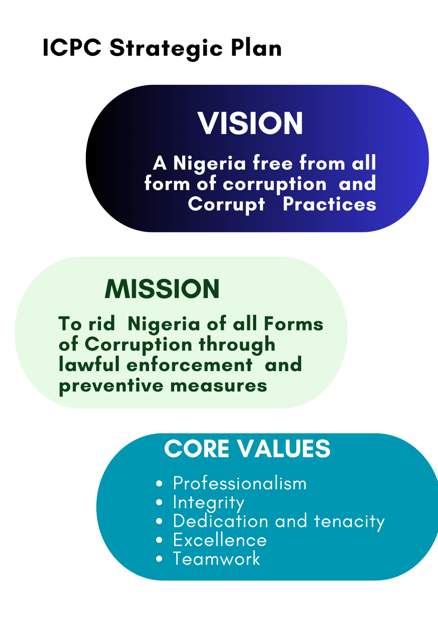
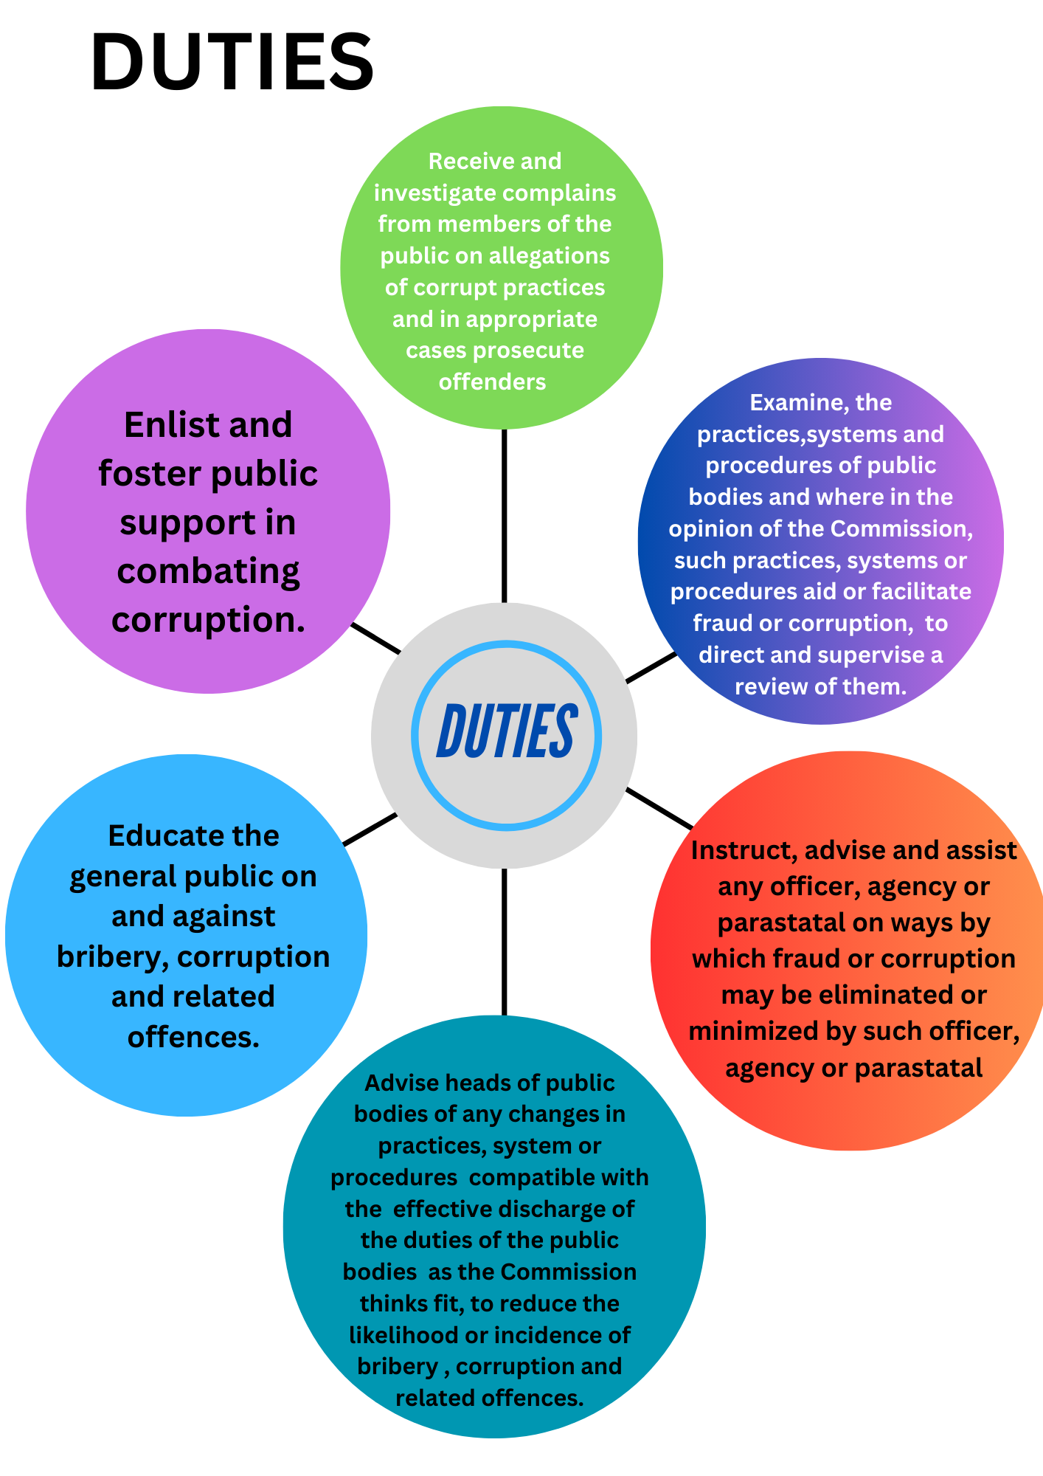
Figure 1

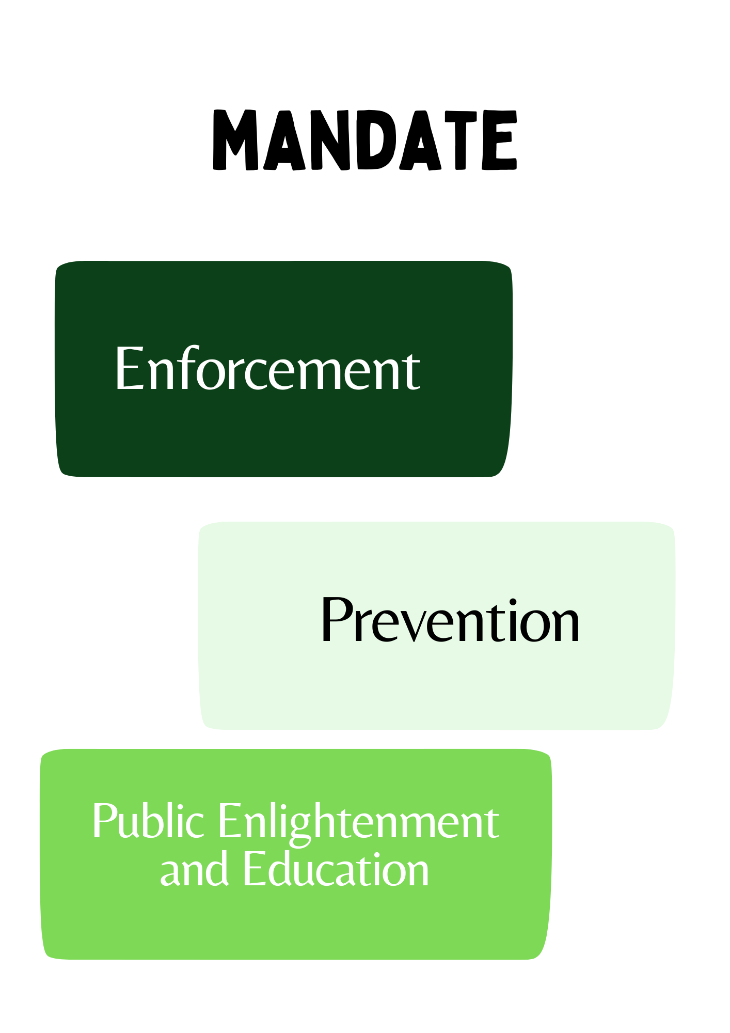

5.0 ENFORCEMENT ACTIVITIES
Resolute and honest enforcement of sanctions are critical deterrence tools if the war against corruption is to enjoy meaningful credibility. Therefore section 6 (a) of the Corrupt Practices and Other Related Offences Act 2000 empowers the Commission with an enforcement mandate which grants it the statutory responsibility of receiving petitions from members of the general public, initiating investigations on corruption and other related offences as well as prosecuting those alleged to have violated the provisions of the act. In the delivery of this mandate, the following activities have been carried out within the year 2024:
5.1 Receipt of Petitions
The Commission receives report on incidences of corruption from members of the public either in form of petitions submitted or via other channels which are then processed and assigned for investigation based on the directives of the Chairman of the Commission.
In the year 2024, the Commission received a total of Nine Hundred and Fifty-Eight (958) petitions out of which Three Hundred and Eighty (380) petitions were assigned for investigation, Two Hundred and Twenty-Four (224) petitions were forwarded to other agencies while Three Hundred and Thirty - Eight (338) cases were closed for being outside the Commissions mandate, based on legal advice. Please note, the differentials of Sixteen (16) are petitions in transit but concluded in 2024.

Geo-Political Spread of Petitions Received
Geo-Political Zone | NC | NE | NW | SS | SW | SE | DIASPORA | TOTAL
Number of Petitions Received | 460 | 91 | 83 | 102 | 143 | 76 | 3 | 958

The Commission recorded 19.29% decrease in the number of petitions received in 2024 compared to the one thousand one hundred and eighty - seven (1,187) petitions received in 2023.

The summary of the petitions received monthly in the year 2024 are as follows:
Month | Jan | Feb | Mar | Apr | May | Jun | Jul | Aug | Sep | Oct | Nov | Dec | Total
No. of Petitions | 68 | 110 | 98 | 74 | 65 | 44 | 77 | 113 | 39 | 186 | 59 | 25 | 958

5.2 Investigation Activities
Upon receipt of petitions either submitted to the Commission or from recommendations arising from the conduct of System Study & Review, Monitoring and evaluation reports as well as intelligence harnessed from suspected corruption activities, the process of investigation on such petition (allegations of corruption) then commences at the directive of the Hon, Chairman of the Commission. These cases are assigned to the different investigative departments/divisions and state offices for investigation.
During the year under review, a total of Three Hundred and Eighty (380) petitions were assigned for investigation, Ninety-Five (95) cases were concluded.
The number of cases concluded in 2024 indicated a decrease of 47.22% compared to cases concluded in 2023 with One Hundred and Eighty (180).
Monthly summary of the investigations concluded in 2024
Month | Jan | Feb | Mar | Apr | May | Jun | Jul | Aug | Sep | Oct | Nov | Dec | Total
No. of cases concluded | 6 | 5 | 16 | 5 | 4 | 5 | 15 | 6 | 5 | 14 | 2 | 12 | 95

5.3 Prosecution Activities
After discreet and meticulous fact-finding activities are carried out by the Operations Department and a prima facie case is established, the cases are then forwarded to the Legal Services Department for prosecution as enshrined in enforcement mandate of the commission in Section 6 (a) of the Corrupt Practices and Other Related Offences Act 2000.
In 2024, the Legal Services Department filed Seventy-One (71) cases in Court and secured Fifteen (15) convictions as against 2023 records, where Sixty-Three (63) cases were filed and Eighteen (18) convictions secured. This indicates a 12.69% increase in the cases filed and 16.7% decrease in the number of convictions secured.
Monthly summary of the cases filed in court and convictions secured in 2024
Month | Jan | Feb | Mar | Apr | May | Jun | Jul | Aug | Sep | Oct | Nov | Dec | Total
No. of cases filed in court | 8 | 1 | 10 | 9 | 15 | 5 | 6 | 1 | 6 | 5 | 2 | 3 | 71
Convictions secured | 2 | 1 | 1 | 0 | 5 | 1 | 2 | 0 | 1 | 1 | 0 | 1 | 15

5.4 Assets Recovery and Forfeiture Activities
In line with the provision of the sections 45-48 of the ICPC Act 2000, the Commission is empowered to recover proceeds of corruption/ corrupt practices via seizures and forfeiture of assets. The Commission in 2024 through its enforcement activities recovered assets worth ₦33.20 billion.
The summary of the recoveries per month within the year 2024 are given as follows:
Month | Value of Assets (₦)
January | 30,276,556.70
February | 430,511,894.60
March | 1,258,047,079.48
April | 200,091,819.76
May | 177,480,702.26
June | 138,771,516.05
July | 433,733,257.12
August | 4,804,794,166.62
September | 21,460,228,856.14
October | 132,138,226.24
November | 618,182,776.82
December | 1,128,362,141.15
TOTAL | 30,812,618,992.94

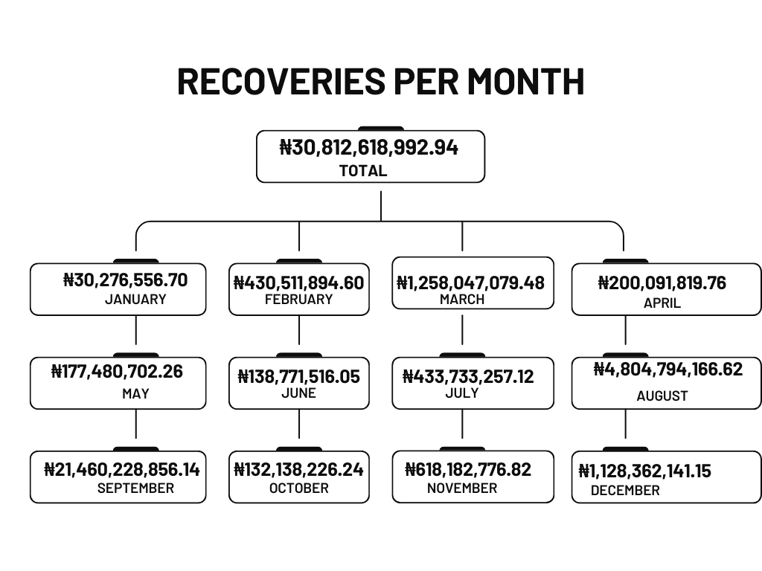

Physical Asset Recovery
ITEMS | Nos | VALUE
Vehicles | 15 | N24M
Business | 3 | N32.7m
Plot of land | 6 | N1.1B
Buildings | 12 | N1.097B
FARM | 1 | N56.4M
Electronics | 1 | N8.8M
Total | 38 | N2.38B
The data on recovery have been captured under “Assets Recovery”

Table Comparing Operational Results
ENFORCEMENT ACTIVITIES | 2023 | 2024 | PERCENTAGE DECREASE | PERCENTAGE INCREASE
Petitions Received | 1187 | 958 | 19.29%
Investigations Concluded | 180 | 95 | 47.22%
Cases Filed in Court | 63 | 71 |  | 12.69%
Convictions Secured | 18 | 15 | 16.66%
Assets Recovered (N’Bn) | 66.89 | 33.20 | 50.36%

5.5 Constituency & Executive Projects Tracking Initiative
The Constituency & Executive Projects Tracking Initiative was Initiated in exercise of the Commission’s enforcement and preventive mandate as provided in the ICPC Act, 2000 with the objective of ensuring improved service delivery, value for money, compliance with the regulatory requirements in the implementation of public funded project; amongst others while also instilling accountability and transparency in the process.
This exercise is usually carried out in collaboration with Local Communities and other Critical Stakeholders including the Civil Society Organization (CSOs). In the year 2024, the Commission embarked on phase VII of the tracking exercise with the following records to present viz-à-viz the 2023 records.

DESCRIPTION | VALUE (₦)  2023 | VALUE(₦) 2024
Cash Recovery | 369,175,734.20 | 369,175,734.20
Projects completed or contractors forced to return to site as a result of CEPTG | 29,590,968,595.25
Assets Recovered | 513,317,404.04
Savings to Government | 29,960,141,329.84
Total no of Projects identified | 2,001 | 1500
Total no of Projects inspected | 1721 | 1133
No. of Projects remaining to be inspected | 280 | 367
No. of projects completed | 1492 | 981
No. of projects ongoing | 136 | 114
No. of projects contractors returned to site | 176
*The data on recovery have been captured under “Assets Recovery’’

.

5.6 Digital Forensic Examination
Emerging trends indicate an increased opportunity for cybercrime, making advances in the law enforcement, legal, and forensic computing technical arenas imperative
Recognizing the above, the ICPC reinforced its Computer Security and Forensic Unit (CSFU) that now ensures that investigations are aided by high quality forensic analysis of Information and Communication Technology Devices. Analysis of disputed documents and conduct of forensic polygraph examination are carried out where necessary by the Unit to ensure efficacy in the delivery of investigative results. Below are the breakdown of the activities of the Unit within the period under review:

- Twenty-Four (24) Phones, were successfully analysed.
- Polygraph examination was successfully administered on Forty- Five (45) persons
- Five (5) disputed documents were successful analysed

6.0 PREVENTION ACTIVITIES
Prevention plays a crucial role in combating corruption. It helps tackle corruption before it can result in serious negative consequences and helps address its root causes. Section 6 (b-d) of the ICPC Establishment Act is the preventive mandate which confers powers on the Commission to examine systems and processes of public organizations with a view to identifying loopholes that allow corrupt practices to thrive and to advise and direct the correction of such lapses. Effective preventive strategies and measures strengthen integrity of public institutions and public officials and promote public trust and confidence in their actions

6.1 System Study & Review and Corruption Risk Assessment
System Study & Review is one effective preventive strategy and measure that strengthen integrity of public institutions and public officials and also promote public trust, which the Commission utilizes in the prevention of corruption through reviewing the processes, systems and procedures through studying the management structures, internal controls, operational procedures and cultures and stakeholder perceptions of Ministries, Departments and Agencies (MDAs) for corruption prone areas and drawing up guide for correction of identiﬁed loopholes to guard against corruption and corrupt practices.
The Corruption Risk Assessment (CRA) is a diagnostic tool which seeks to identify weaknesses within a system which may present opportunities for corruption to occur, hence adopting the approach of analysing and estimating the likelihood and impact of corruption on an organisation or sector through careful environmental, organisational, sectoral and personnel analyses.
In the year 2024, the Commission conducted Twenty-Four (24) System Study and Review, One (1) Corruption Risk Assessments (CRA) on public organizations.

SYSTEM STUDIES AND REVIEW CONDUCTED
S/N | MDAs | Location
1 | National Space Research Development Agency | Abuja
2 | Nigeria Incentive-Based Sharing System for Agricultural Lending | Abuja
3 | Small and Medium Enterprise Development Agency of Nigeria | Abuja
4 | Federal Ministry of Interior | Abuja
5 | National Social Insurance Trust Fund | Abuja
6 | Federal Road Maintenance Agency | Abuja
7 | National Directorate of Employment | Abuja
8 | Federal Competition and Consumer Protection Commission | Abuja
9 | National Emergency Management Agency | Abuja
10 | National Office for Technology Acquisition and Promotion | Abuja
11 | National Commission for Colleges of Education | Abuja
12 | Federal Ministry of Labour and Employment | Abuja
13 | Police Trust Fund | Abuja
14 | Upper Benue River Basin Development Authority | Yola, Adamawa State.
15 | Electronic Equipment Development Institute, Awka | Awka, Anambra State.
16 | Federal polytechnic, Daura | Daura, Katsina State.
17 | Scientific Equipment Development Institute, Enugu | Enugu
18 | Nigerian Institute of Trypanosomiasis Research | Kaduna
19 | Hadejia-Jama’are River Basin Development Authority | Hotoro, Kano State.
20 | Hydroelectric Power Producing Areas Development Commission | Minna, Niger State.
21 | Federal College of Education (Special) | Ibadan, Oyo State.
22 | Prototype Engineering Development Institute | Ilesha
23 | Federal Polytechnic, Ile- Oluji | Ondo
24 | Sokoto Rima Basin and Rural Development Authority | Sokoto

6.2 Ethics & Integrity Compliance Scorecard
One of the strong initiatives of the ICPC which has since 2019 gained publicity is the annual deployment of the Ethics and Integrity Compliance Scorecard (EICS) in Federal Government Ministries, Department and Agencies (MADs). EICS (which is also referred to as the scorecard) is an evaluation tool conceived and developed by the ICPC under its preventive mandated as stipulated in section 6(b-d) of the Corrupt Practices and Other Related Offences Act 2000.
The EICS is patterned as a questionnaire that seeks to measure institutional integrity and accountability in MDA operation as well as encourage innovation, productivity and creativity in enhancing their systems and operations while also serving as check for deviations from expected ethics and integrity standards in the public service.
In 2024, Ethics and Integrity Compliance Scorecard was deplored in Three Hundred and Thirty (330) MDAs out of which Three Hundred and Eight (308) was successfully assessed, Fifteen (15) MDAs were non-responsive and 7 MDAs exempted based on exigent government policy, leaving only Two Hundred and Eight-Six (286) MDAs for actual assessment. The results summary is shown below viz -a- viz the result of 2023.

Compliance Level | Number of MDAs
Compliance Level | 2023 | 2024
Full Compliance | 0 | 0
Substantial Compliance | 39 | 91
Partial Compliance | 219 | 159
Poor Compliance | 80 | 49
Non-Compliance | 30 | 9
Non-Responsive | 36 | 15
No. of MDAs Exempted | 0 | 7
Total | 404 | 330

The ranking of the MDAs was based on the level of compliance and adherence to the measures on the Ethics and Integrity Compliance Scorecard as indicated in the table above. The three major thematic areas of assessment are: Management Culture & Structure – 30%; Financial Management Systems – 40%; and Administrative Systems – 30%. The assessment result of the MDAs has been published.

6.3 Inauguration of Anti-Corruption and Transparency Units (ACTUs)
To enhance institutional integrity which is necessary to establish the desired standard of morality in the execution of government businesses in MDAs as well serves as an instrument in ensuring the cultivation of the required level of discipline and accountability in the conduct of public officers with the aim of preventing corruption, the Commission initiated the Government Circular No: OHCSF/MSO/192/94 in October 2001, for the establishment of Anti-Corruption and Transparency Unit (ACTU) in MDAs.
The ICPC has inaugurated ACTUs in over Four Hundred and Thirty (430) MDAs. Eighty (80) more ACTUs were inaugurated across different MDAs in 2024.
6.4 ACTU Effectiveness Index
The nature of ACTU as a microcosm of the ICPC and also as an indicator have necessitated the need to provide a special tool to assess it. The ACTU Effectiveness Index (AEI) was developed as an assessment tool to measure the performance and impact of ACTUs in their MDAs as the effectiveness of ACTU should reflects in effective accountability systems in MDA operations, improved service delivery and social benefits to stake holders and the citizenry. The ACTU Effectiveness Index (AEI) Template was deployed in Three Hundred and Eight (308) MDAs nationwide and Two Hundred and Sixteen (216) MDAs successfully completed and returned the Index Template. However, a total of Ninety-Two (92) MDAs had no ACTUs at the time of the deployment.
The results from the exercise revealed the following:
Effectiveness | 2023 |  | 2024
Effectiveness | Number | Percentage | Number | Percentage
Very Effective | 15 | 3.71% | 26 | 8%
Effective | 70 | 17.33% | 58 | 19%
Ineffective | 173 | 42.82% | 127 | 41%
Dormant | 12 | 2.10% | 5 | 2%
Non-existent | 134 | 33.17% | 92 | 30%
TOTAL | 404 | 100% | 216 | 100%

6.5 Corruption Monitoring Activities
To ensure the domestication of the culture of transparency, accountability and ensure integrity in the processes and systems of public organizations, ICPC engages in corruption monitoring activities in the areas of procurement processes; Recruitment processes, examination monitoring, budget implementation monitoring, verification processes, election monitoring, etc, with a view to ensuring corruption-free driven process in the exercises.
Within the year under review, the Commission conducted Nine (9) monitoring activities in MDAs which involved: monitoring of bid openings; promotion interviews/examinations; recruitment processes.
7.0 PUBLIC ENGAGEMENT
Public Enlightenment and Education Department of the Independent Corrupt Practices and other related Offences (ICPC) was established in line with Section 6 (e – f) of the Corrupt Practices and Other Related Offences Act, 2000 which states that it shall be the duty of the Commission to educate the public on and against bribery, corruption and other related offences; and to enlist and foster support in combating corruption.
By this mandate, the Commission is saddled with the duties of identifying stakeholders, designing projects, programmes, and information resource materials and carrying out activities to serve as outreach initiatives and mobilizing stakeholders against corruption.
The department carried out the following activities in the year under review:
7.1 Sensitization Sessions
To foster the needed drive and stem the tide of corruption in our society, in the year under review, the commission further strengthen its function of educating and mobilizing Nigerians through sensitisation sessions which are aimed at building their capacity on issues of corruption/anti-corruption.
During the year 2024, the ICPC organised Five Hundred and Seventy-Nine (579) sensitisation sessions with a total attendance of Three Hundred and Sixty-Two Thousand and One Hundred (362,100) participants from different sectors and strata of the Nigeria public

Sensitization Sessions conducted | 2023 | 2024
Total | 841 | 579

Sensitization Sessions conducted
TABLE SHOWING DISTRIBUTION OF SENSITIZATIONS CONDUCTED BY THE COMMISSION 2024
 |  | Jan | Feb | Mar | Apr | May | Jun | Jul | Aug | Sep | Oct | Nov | Dec | TOTAL
1 | Adamawa |  |  | 3 |  | 3 | 1 | 1 |  |  | 3 | 2 | 1 | 14
2 | Akwa-Ibom | 2 |  | 1 |  | 1 |  | 2 |  |  |  | 1 |  | 7
3 | Bauchi |  |  |  |  |  |  |  |  |  |  |  | 1 | 1
4 | Benue |  | 2 | 1 |  | 1 |  | 1 |  |  | 1 |  |  | 6
5 | Edo |  |  |  |  |  |  |  |  |  |  |  | 2 | 2
6 | Enugu | 1 | 3 | 1 |  | 2 | 3 | 4 |  |  |  |  | 2 | 16
7 | Imo |  | 2 |  | 2 | 1 | 1 | 3 | 1 | 2 |  | 1 |  | 13
8 | Kaduna | 1 |  | 1 |  | 1 |  | 1 | 1 |  |  |  |  | 5
9 | Kano |  |  | 5 |  | 1 |  |  |  | 5 |  |  |  | 11
10 | Kogi |  |  | 1 | 1 | 1 |  |  |  | 1 |  |  | 2 | 6
11 | Lagos | 1 | 1 | 2 |  |  |  | 2 |  |  |  |  | 1 | 7
12 | Oyo |  | 4 |  |  |  |  |  |  |  |  |  |  | 4
13 | Osun | 3 | 6 | 4 |  | 2 |  | 1 |  | 2 | 1 |  | 1 | 20
14 | Rivers |  |  |  |  | 1 |  | 2 | 2 | 2 | 1 | 2 |  | 10
15 | Sokoto | 2 | 2 | 1 |  |  |  | 2 |  |  |  |  | 1 | 8
16 | Katsina |  | 2 |  |  |  |  |  |  | 2 |  | 1 | 2 | 7
17 | Ondo | 2 | 5 | 3 | 3 | 4 | 1 |  | 2 | 1 |  |  | 2 | 23
18 | Niger | 7 |  | 2 |  | 1 | 2 | 3 |  | 2 |  |  | 1 | 18
19 | Borno |  |  | 1 |  | 1 |  |  |  |  |  |  |  | 2
20 | Anambra |  |  |  |  | 2 |  | 1 |  |  |  |  |  | 2
21 | Delta |  | 4 |  |  |  | 1 |  |  |  |  | 4 | 2 | 11
22 | Educ. Dept | 15 | 17 | 7 | 4 | 18 | 6 | 7 | 5 | 4 | 0 | 0 | 0 | 83
23 | P.Enlighten. | 19 | 34 | 22 | 6 | 23 | 10 | 25 | 6 | 13 | 10 | 11 | 18 | 197
24 | SSRD | 6 | 4 | 5 | 8 | 7 | 3 | 12 | 12 | 14 | 11 | 4 | 20 | 106
 | TOTAL |  |  |  |  |  |  |  |  |  |  |  |  | 579

7.2 The National Ethics & Integrity Policy (NEIP)
To sustain the promotion of the core values of honesty, integrity, accountability and transparency, as contained in the National Ethics and Integrity Policy, the commission continued its collaborative sessions across the nation. The policy which was developed and launched in 2020 in collaboration with the Office of the Secretary to the Government of the Federation (OSGF) and the National Orientation Agency (NOA) contains seven core values namely: Human Dignity, Voice and Participation, Patriotism, Personal Responsibility, Integrity, National Unity and Professionalism. These values are aimed at encouraging citizens to put Nigeria first above all things and restore a safe and ethical society. The Commission in 2024 drove the implementation of the policy through the conduct of Five (5) Zonal Stakeholders Dialogue sessions across the country.
7.3 Anti-Corruption Initiatives with Civil Society Organizations
In an effort to reach a greater populace, the ICPC collaborates with Civil Society Organizations (CSOs) to mobilize the citizenry on the need to shun acts of corruption, report corrupt practices and be involve in the anti-corruption crusade.
To this end, nine (9) new CSOs were registered with the ICPC under the National Anti-Corruption Coalition (NACC). Meanwhile Twenty-four (24) anti-corruption activities were undertaken by ICPC supported CSOs platforms aimed at engaging the public in the fight against corruption in Nigeria as shown in the table below:

NUMBER OF CSOs-SUPPORTED ACTIVITIES
 |  | Jan | Feb | Mar | Apr | May | Jun | Jul | Aug | Sep | Oct | Nov | Dec | TOTAL
1 | Adamawa |  |  |  |  |  |  |  |  |  |  |  |  | 0
2 | Akwa-Ibom |  |  |  |  |  |  | 1 |  |  |  |  |  | 1
3 | Bauchi |  |  |  |  |  |  |  |  |  |  |  |  | 0
4 | Benue |  |  |  |  |  |  |  |  |  |  |  |  | 0
5 | Edo |  |  |  |  |  |  |  |  |  |  |  |  | 0
6 | Enugu |  |  |  |  |  |  |  |  | 1 |  |  |  | 1
7 | Imo |  |  |  |  |  |  |  |  |  |  |  |  | 0
8 | Kaduna |  | 1 |  |  |  |  |  |  | 1 |  |  |  | 2
9 | Kano |  | 1 |  |  |  |  |  |  |  |  |  |  | 1
10 | Kogi |  |  |  |  |  |  |  |  |  |  |  |  | 0
11 | Lagos |  | 1 |  | 2 | 2 | 1 | 1 | 1 |  |  | 2 | 1 | 11
12 | Oyo |  |  |  |  |  |  |  |  |  |  |  |  | 0
13 | Osun | 1 |  | 5 | 1 |  |  |  |  |  | 2 |  |  | 9
14 | Rivers |  |  |  |  |  |  |  |  |  |  |  |  | 0
15 | Sokoto |  |  |  |  |  |  |  |  |  |  |  |  | 0
16 | Katsina |  |  |  |  |  |  |  |  |  |  |  |  | 0
17 | Ondo |  |  | 1 |  |  |  |  |  |  |  | 1 |  | 2
18 | Niger |  |  |  |  |  |  |  |  |  |  | 1 |  | 1
19 | Borno |  |  |  |  |  |  |  |  |  |  |  |  | 0
20 | Anambra |  |  |  |  |  |  | 1 |  |  |  |  |  | 1
21 | Delta |  |  |  |  |  |  |  |  |  | 1 |  |  | 1
22 | Educ. Dept. |  | 1 |  | 1 | 2 |  | 3 | 1 | 1 | 3 | 3 | 2 | 17
 | TOTAL | 1 | 4 | 6 | 4 | 4 | 1 | 6 | 2 | 3 | 6 | 7 | 3 | 47

7.4 Formation of Anti-Corruption Clubs and Vanguards
For the purpose of instilling virtues of transparency/accountability and building strong moral values in youth that will promote the culture of integrity and contribute to the ethical tone of Nigeria and encourage them to shun corruption, Student Anti-Corruption Clubs (SAC) and Student Anti-Corruption Vanguards (SAV) are clubs formed in secondary and tertiary institutions respectively. To this end, the ICPC grooms pupils and students in educational institutions through the formation of Anti-Corruption Clubs in primary and secondary schools and Anti-Corruption Vanguards in tertiary institutions. The pupils/students are empowered with the required knowledge and materials to organise advocacy sessions on Anti-Corruption in their respective institutions. Within the year 2024, One Hundred (100) Student’s Anti-Corruption Clubs and Eighteen (87) Student Anti-Corruption Vanguards were formed nationwide.

NUMBER OF ANTI-CORRUPTION CLUBS AND VANGUARDS FORMED BY THE COMMISSION IN 2024
 |  | Jan | Feb | Mar | Apr | May | Jun | Jul | Aug | Sep | Oct | Nov | Dec | TOTAL
1 | Adamawa |  |  |  |  |  |  |  |  |  |  |  |  | 0
2 | Akwa-Ibom | 2 |  |  |  |  |  |  |  |  |  |  |  | 2
3 | Bauchi |  |  |  |  |  |  |  |  |  |  |  |  | 0
4 | Benue |  |  |  |  |  |  | 1 |  |  |  |  |  | 1
5 | Edo |  |  |  |  | 1 |  |  |  |  |  |  |  | 1
6 | Enugu |  |  |  |  |  | 1 |  |  |  |  | 1 |  | 2
7 | Imo |  | 2 | 2 |  | 1 |  |  |  | 1 | 1 | 1 |  | 8
8 | Kaduna |  |  |  |  |  |  |  |  |  |  | 31 |  | 31
9 | Kano |  |  |  |  | 2 |  |  |  |  |  |  |  | 2
10 | Kogi |  |  |  |  | 1 |  |  |  |  |  |  |  | 1
11 | Lagos |  |  |  |  |  | 1 |  |  |  | 1 |  |  | 2
12 | Oyo |  |  |  |  |  |  |  |  |  |  |  |  | 0
13 | Osun |  |  |  |  |  |  |  |  |  |  |  |  | 0
14 | Rivers |  |  |  |  | 1 | 2 |  |  |  |  |  | 25 | 28
15 | Sokoto |  |  |  |  |  |  |  |  |  |  |  |  | 0
16 | Katsina |  | 2 |  |  |  |  |  | 1 |  | 1 | 1 |  | 5
17 | Ondo |  |  |  |  |  |  |  |  |  |  |  | 30 | 30
18 | Niger |  | 2 |  |  |  | 1 |  |  |  |  |  | 35 | 38
19 | Borno |  |  |  |  |  |  |  |  |  |  | 3 |  | 3
20 | Anambra |  |  | 1 |  |  |  |  |  |  |  |  |  | 1
21 | Delta |  |  |  |  | 1 | 4 | 1 |  |  | 3 | 6 |  | 15
22 | Educ. Dept |  | 3 | 1 |  |  | 2 |  |  |  |  | 1 |  | 7
 | TOTAL | 2 | 9 | 4 | 0 | 7 | 11 | 2 | 1 | 1 | 6 | 44 | 90 | 177

7.5 Television and Radio Programmes
The Commission leveraging on the transformative potentials of mass media and its ability to disseminate well defined behavioral focused messages to large audience repeatedly, uses the Television and Radio platform to enlighten and engage the public in combating the ills of corruption. Within the year under review, the summary of the engagement are as follows:
- Thirty-Six (38) episodes of “Transparency Files” were aired on Television in English language;
- One Hundred and Fifty-Four (154) episodes of language television interviews were aired in three Nigerian languages (Hausa, Igbo & Yoruba);
- Five (5) interviews were granted to radio, Television and Newsprint
  - Social Media
Summary of the social media followership within the period viz-a-viz 2023 as follows:

Social Media | Year | Facebook | Instagram | Twitter | YouTube | website | Opera News | Total
Hits and Feedbacks | 2023 | 1,095,598 | 171,231 | 5,436,700 | 46,747 | 802,757 | 524,911 | 8,077,944
Hits and feedbacks | 2024 | 564,538 | 187,164 | 590,581 | 35.975 | 217,844 | 89,418 | 1,685,520

8.0 THE ANTI-CORRUPTION ACADEMY OF NIGERIA
The Anti-Corruption Academy of Nigeria (ACAN) was established in 2015 as the research and training arm of the Commission. The Academy’s philosophy is that corruption can be controlled through robust training and re-training of public and private officers on ethics, integrity, anti-corruption and good governance. Such trainings are grounded in sound policy formulation, operational efficiency, good management culture, ethical behaviour and required to drive a corruption-free society. In furtherance to the assertion above, the Academy carried out the following initiatives and reforms:
- Developed a norm and behaviour change curriculum for Chief Executive Officers (CEOs) of key public sector agencies. The curriculum was also used to develop their skills to implement countermeasures for corruption-inducing social norms and expectations. A major outcome of the training was that CEOs are able to mentor and develop the capacity of their subordinates to tackle corruption in their domains;
- Held a parley with the Nigeria Union of Journalists (NUJ) to deliberately involve the Union, and by extension, journalists, in educating and mobilizing the public on the ills of corruption. It highlighted the need for Journalists to emphasize corruption prevention and foster public support in the fight against corruption. The role of NUJ in the implementation of the National Anti-Corruption Strategy (NACS) was also identified and emphasized.
c) Held capacity building programmes for investigators and prosecutors on Anti-Money Laundering and Countering the Financing of Terrorism, Asset Tracing and Recovery, Mutual Legal Assistance, to improve their knowledge and skills.
d) Organized twenty-eight (28) training programmes for public officials, including members of Anti-Corruption and Transparency Units (ACTUs) in various MDAs.
A total of Two Thousand, One Hundred and Sixty-Eight (2,168) participants were trained through Twenty-Eight (28) programmes at ACAN in 2024 (See Summary of programmes overleaf). This is a 3.52% decrease in the number of participants trained in 2023 in which Two Thousand Two Hundred and Forty-Four (2,244) participants were trained.
Month | Year | Jan | Feb | Mar | Apr | May | Jun | Jul | Aug | Sep | Oct | Nov | Dec | Total
No. of Participants | 2023 | 0 | 12 | 0 | 115 | 168 | 367 | 169 | 664 | 157 | 143 | 300 | 149 | 2,244
No. of Participants | 2024 | 100 | 95 | 134 | - | 142 | 469 | 127 | 185 | 324 | 144 | 335 | 113 | 2,168
The monthly summary of participants recorded is as follows:

S/NO. | PROGRAMMES | TARGET PARTICIPANTS | NO. OF PARTICIPANTS
1 | Bespoke Capacity Building Workshop on Achieving Zero-Tolerance for Corruption in the Workplace for Officials of Petroleum Technology Development Fund (PTDF) | Senior Staff of Petroleum Technology Development Fund (PTDF) | 100
2 | Induction Training Programme for ICPC Officers | Newly recruited ICPC Cadets (Senior Staff) | 95
3 | Workshop on Anti-Money Laundering, Countering the Financing of Terrorism and Combating Proliferation Financing | ICPC Officers involved in Investigation | 134
4 | Workshop on Administrative Measures for Controlling Workplace Corruption | Admin/HR/Inventory/Stores/Registry Officers | 87 (84 Onsite + 3 Online)
5 | Strategic Communication Workshop | Information, PR, Protocol & Media Officers | 55 (51 Onsite + 4 Online)
6 | ACTU Workshop on Budget Tracking | ACTU Chairmen, Secretaries & Members | 194 (190 Onsite + 4 Online)
7 | Anti-Corruption & SDGs Workshop for Youth Corps | SDGs CDS Youth Corps Members, Keffi | 51
8 | Certificate Course in Corruption Prevention (CCCP) | Officers of ACAs, ACTUs, Ethics & Compliance | 48
9 | Workshop on AML/CFT | ICPC Investigators and Prosecutors | 176
10 | Combating Corruption in Public Procurement | Procurement and Project Officers | 78 (70 Onsite + 8 Online)
11 | Capacity Building for Jigawa House of Assembly | Members of Jigawa State HoA | 49
12 | Workshop on Forensic Accounting and Auditing | Accountants, Auditors, ACTUs, Compliance Officers | 84 (80 Onsite + 4 Online)
13 | Capacity Building for Taraba & Benue HoA | Members of Taraba and Benue HoA | 29
14 | Workshop on Illicit Financial Flows | Investigators, Auditors, Compliance Officers | 72 (69 Onsite + 3 Online)
15 | Certificate Course in Corruption Investigation (CCCI) | Investigators, ACTUs, Compliance & Audit Officers | 62
16 | Workshop on Corruption Control for National Development | Public Officers from States and LGs | 79 (57 LGAs + 22 States)
17 | Training on AML/CFT for DNFBPs | ICPC Investigation & Prosecution Officers | 23
18 | Project Management Workshop | Procurement/Project Officers from MDAs/HEIs | 80 (75 Onsite + 5 Online)
19 | Transparency in Basic Education | SUBEBs/FCT-UBEB Chairs, VCs, Directors | 66
20 | Anti-Corruption Campaign Training (NCDMB) | ACTU Members & Officials of NCDMB | 14
21 | Anti-Corruption Campaign Training (NUPRC) | ACTU Members & NUPRC Officials | 23
22 | Anti-Corruption Leadership Series | GL 12+ Officers with Leadership Potential | 37
23 | AML/CFT Training for DNFBPs | ICPC Investigation & Prosecution Officers | 26
24 | Senior Executive Course Series | Assistant Directors and Above | 26 (25 Onsite + 1 Online)
25 | Certificate Course in Ethics and Compliance (CCEC) | Ethics/Compliance/ACTU/IC Officers | 32 (31 Onsite + 1 Online)
26 | Confronting Corruption through Collective Action | ACTU Chairmen, Secretaries & Members | 260 (250 Onsite + 10 Online)
27 | Executive Session of ICPC Chairman with CEOs | CEOs of Public Sector Agencies | 75
28 | Corruption Risk Assessment Training | ACTUs, Ethics, Risk, Audit, SERVICOM Officers | 113 (103 Onsite + 10 Online)

SUMMARY OF 2024 ACAN PROGRAMMES

Total as @ 31 December 2024 = 2,168 Participants in 28 Training Programmes (2,112 Onsite + 53 Online)

9.0 ADMINISTRATION & SUPPORT SERVICES
9.1 Office of the Secretary to the Commission
The Commission coordinates all its administrative matters through the Office of the Secretary to the Commission. The office had facilitated the following in 2024
- The review and adoption of the ICPC Scheme of Service
- Review of the ICPC Conditions of Service
- Board and Management Retreats
- Several Board meetings
- Review and approval of the 2024 promotion exercise
- Board and Committee of Directors Meetings
9.2 Staff Distribution
The staff strength of the Commission as at the end of year 2024 stood at One Thousand, One Hundred and Eighty-Three (1,183) which includes the Chairman of the Commission, the Board members and Secretary to the Commission.
The distribution of staff by grade level and gender is given as follows:
GRADE LEVEL | GENDER |  | TOTAL
GRADE LEVEL | Male | Female | TOTAL
01 – 06 | 204 | 59 | 263
07 – 10 | 308 | 110 | 418
12 – 14 | 233 | 112 | 345
15 – 17 | 115 | 29 | 144
Special Grade | 9 | 4 | 13
TOTAL | 869 | 314 | 1,183

9.3 Manpower Development
Attention was given to improving and optimizing the skills, knowledge and capabilities of the workforce to enhance productivity, efficiency and overall effectiveness. In this regard, the Commission provided opportunities for staff to be trained in various fields at the Commission’s Academy and other training facilities within and outside the country.
The summary of the number of staff that participated in capacity building programmes within the year are given thus:
S/N | Total No. of Courses | No. of Participants | Sponsor
1 | 39 Capacity Building Programmes | 197 | ICPC/other Stakeholders, Development Partners, International Non- Governmental Organization e.t.c

  - Career Progression (2024 Promotion Examinations)
The Commission actively support and encourages career progression of its staff while also seeking opportunity for growth and development. In 2024, promotion examinations were conducted for staff who were due for promotion. At the end of the exercise, One Hundred and Seventy-Two (172) staff were promoted to the next grade level.
Summary of the promotion exercise and upgrade is given as follows:
No. Due for promotion | No. of Staff promoted | No. Due for Upgrade | No. of Staff Upgraded | Conversion
235 | 172 | 3 | 2 | 6

The Commission also conducted examination for six (6) staff who had obtained additional qualifications in the course of their careers.
9.5 Staff Application/Request and other Routine Activities
On the issues bordering on staff request, application and administration, a total of Two Thousand, Four Hundred and Eighty-Nine (2,489) personnel and administrative files were processed and dispatched and Eight Hundred and Ninety Six (896) memos were routed and circulated in the year under review.
9.6 Finance and Accounts
The Finance and Account Department in compliance with the Commission Electronic Data Management System (EDMS) policy scanned all its capital and overhead vouchers.
The Department also reviewed a total of Thirty-One (31) MDAs through the Open Treasury Portal (OTP) to ascertain their level of compliance to financial regulation and budget implementation.
A total of Three Thousand, Two Hundred and Thirty-Four (3,234) vouchers were raised and processed for payments by the Department.
9.7 Planning Research and Statistics (PRS)
The Planning Research and Statistics (PRS) Department is the Commission’s data mining arm responsible for data collection, analysis, storage and dissemination, research, policy formulation, programme and project design, performance monitoring and evaluation, rolling plan preparation as well as external cooperation.
In the year under review, the Planning Research and Statistics Department carried out the following activities:
- Prepared 2023 quarterly and annual reports.
- Facilitated the implementation of the Commission’s Strategic Action Plan.
- Conducted a Strategy Review Session in preparation to the development of a new Strategic Plan 2024-2028.
- Collated/analyzed quarterly, Bi-annual and Annual Statistics on the Commission’s activities.
- Prepared and presented the quarterly Performance Scorecards of the Commission to the Board and Management for review and adoption.
- Monitored the performance of Depts./Units in terms of meeting set targets in the strategic plan.
- Conducted Two (2) surveys on Management and Staff of the Commission to establish the degree of their awareness and compliance with the strategic plan implementation.
- Maintained Inter-Agency liaison with government and non-governmental agencies amongst others.
- Conducted a research on procurement compliance on selected MDAs in Nigeria

9.8 Information & Communication Technology
In continuation of the Commission ‘s commitment to upgrade her services to contemporary standards and put in place a robust Information and Communication Technology (ICT) infrastructure as well as maintained a modern data center, the Commission in the year 2024 carried out the following:
- Development and digitization of the assets recovered by the Commission
- Continued the development of Case Management System for the Commission
- Conducted a review of the Cybersecurity and data protection compliance for the onward transmission to the Federal House of Representatives Committee on ICT.
- Conducted an assessment of the current networking infrastructure within the Commission to prepare for the upgrade of obsolete components and optimizing the system.
- Ensured ICPC Registration as a data controller and data processor on the NDPC portal.
- Conducted data privacy impact assessments (DPIA).
- Performed data privacy gap analysis and audit assessments for each unit and department.
- Presented a Demo of the Case Tracking System for additional inputs from various stakeholders.
- Produced documentation for the Case Tracking System requirements for Record-keeping Purposes, which will serve as a TOR.
- Conducted power audits and maintenance of the 20KVA Hybrid Solar Inverter Backup System, resolving major power issues in the server room to prevent downtime.
- Deployed Task Management Software for the Commission to manage and monitor tasks assigned to various departments/units.
- Migration and upgrade of the Commission’s Website and Mail server to Galaxy Backbone PLC.
- The Commission through its ICT infrastructure was able to host (49) virtual meetings and capacity building programmes.
- Developed the ICT Unit’s 2025 annual work calendar.
- Upgraded the network infrastructure by replacing outdated Cat 5 cables with Cat 6 and installing new LAN ports, Ubiquiti UDM Pro, switches, and Unifi access points, resulting in better network speeds, security, and scalability.
- Improved Wi-Fi coverage across main and extension buildings during the LAN upgrade project
9.9 The Library
The Commission’s library serves as a center that collect and organizes information in various formats that aid staff of the different departments/units of the Commission and external researchers in knowledge development. It offers stock of publications (Law Reports, Textbooks and Journals) amongst other books. which are useful in learning, research and recreation.
The library hosts Ten (10) workstations with electronic copies of the Law Companion and also has copies of the Nigerian Weekly Law Reports and other legal journals for reference.
The library received the following publications during the year:
- Forty-Four (44) copies of Nineteen (19) different textbooks/ journals from MDAs
- One Thousand, Nine Hundred and Twenty-Six (1926) newspaper publications.
- A total of One Hundred and Four (104) books were borrowed from Eleven (11) Departments/Units.

9.10 Access Control & Security Support
The Internal Security and Support Unit (ISSU) of the Commission conducts proper security checks and screening of persons before entry into the Commission to avoid security breaches in and around the Commission’s premises and also to ensure that documentation and protocols are adhered to at the access points.
To this end, a total of Twenty-Three Thousand, Seven-Hundred and Ten (23,710) persons were screened, documented and cleared to access the Commission, by the unit in 2024.
Meanwhile, a total of One Hundred and Thirty (130) suspects were detained at the Commission’s detention facility.
9.11 Procurement
Procurement Unit facilitated the award of the following capital Projects:
- Establishment of an Ethics Pod Studio, Consultancy for Data Protection, Consultancy for the Implementation of ICPC Task Management Platform and Implementation of Information Security Management System (ISO/IEC 27001:2022).
- Additional work on the construction of drainage/culvert and relocation of high-tension poles and accessories
- General Earthing System at Ondo State Office
- Supply and installation of 5.5HP hp Pumping Machine and Recoiling of the Burnt Pumping Machine

The Unit also handled the following activities;
- Issued Forty-eight (48) jobbing orders for printing, repair of office vehicles, supply of office consumables, drugs/medical equipment, ICT hardware/software, Security/Information and Communication Technology equipment amongst others.
- The Unit monitored the ongoing rehabilitation of the ICPC Headquarter and the construction of prototype building in the State offices as well as the renovation of Aphro Plaza Shopping Mall, Gwagwalada Abuja

9.12 Health-Care Services
The Commission has a clinic that is designed to attend to the primary health needs of its staff and suspects in custody. The clinic also attends to relatives of staff. Within the year under review, the statistics of clinical services were reported as follows:
- Three Thousand, Three Hundred and Twenty-Six (3,326) patients (being a summation of staff visit and revisit to the facility)
- Three Hundred and Forty-Nine Thousand, Two Hundred and Ninety- Three (349,293) laboratory tests.
- Two Hundred and Thirty- Six (236) Suspects screened.
Table Showing Clinical Services Data Distribution for 2024
S/N | INDICATOR | DATA
1. | Clinic visit & revisits | 3,326
2. | Laboratory testing | 349,293
3. | Suspects screened | 236

9.13 Reforms/SERVICOM Unit
In 2024, the Reforms/SERVICOM Unit continued its commitment to improving the quality of services rendered by the Commission to the public through systematic reforms and the implementation of Service Compact (SERVICOM) principles. The Unit's activities were guided by the overarching goal of ensuring that services are delivered promptly, fairly, and transparently, in line with stakeholders’ expectations.

The 2024 Annual Report of the Reforms/SERVICOM Unit highlights the achievements of the Unit in enhancing service delivery and implementing reforms within the Commission. The key areas of focus include the statutory duties of the Unit as well as special assignments executed by the Unit in the period under review.

Key Areas of Focus
- On-the-Spot Checks – Unscheduled checks to places of service delivery to check how the services are being delivered.
- Process Monitoring: Observing processes and activities of the Commission to ensure that all stakeholders are fairly treated in line with best practices.
- Sensitization Messages dispatched to staff on ways to improve delivery service.
- Complaints received and handled.
- Programmes organized.
- Surveys conducted.
- Awards received.
- Special assignments
- Meetings attended
- Trainings attended.
- Outcome of the Survey Forms administered to visitors.

Major Accomplishments
- The Commission celebrated the 2024 Customer Service Week in grand style with a Symposium and Award presentations to 23 service providers to ICPC including security personnel and cleaners. There was also morning tea served to officers that arrived early to work during the week.
- The ICPC Service Charter was successfully launched and distributed to staff.
- The Reforms/SERVICOM Unit received 2 awards on behalf of the Commission – Best Performing PSC Nodal Officer, Team A and best Supportive CEO to the Hon. Chairman.
- 8 on-the-spot checks were conducted.
- 5 Process monitoring exercises on Procurement, recruitment and promotion exercises were monitored.
- About 50 sensitization Messages were dispatched to staff on ways to improve delivery service.
- About 20 complaints were received and handled.
- 6 major programmes organized.
- 2 Surveys were conducted – to assess the success of the 2024 Customer Service Week and to assess Staff opinion of the Chairman’s one-year in office.
- About 17 special assignments were executed.
- Over 43 strategic meetings were attended.
- 2 trainings attended.
- 1,380 Survey Forms were administered to visitors.

9.14 External Cooperation
Section 6 of the Corrupt Practices and Other Related Offences Act, 2000 encapsulates the tripod mandates of the Commission. These mandates are investigation and prosecution of corruption and related offences, public enlightenment and education against the ills of corruption and system study and review.
Corruption is no longer local, it has become international and extra territorial. Corrupt individuals do not only keep stolen asset within the country but also launder or transfer them outside the jurisdiction of the victim state or country of origin. This is particularly so in Nigeria in that vast quantity of proceeds of corruption have been transferred outside the jurisdiction of Nigeria and are yet to be repatriated or recovered.
Where investigation is extra-territorial or stolen asset are kept outside the jurisdiction, successful investigation cannot be achieved or such asset cannot be recovered without international cooperation.
International cooperation has increased in scope in modern times. It is no longer limited to Mutual Legal Assistance (MLA) in the investigation and recovery of stolen asset but has also extended to technical assistance to increase the capacity of states to fight corruption and related offences.
In furtherance of its international cooperation initiatives, the Commission in 2024 has signed Memoranda of Understanding with Anti-Corruption Commission of the State of Palestine, International Anti-Corruption Academy (IACA) and Coalition for Dialogue on Africa (CoDA) and also establish partnership and participated in Multi-Stakeholder Capacity Building Programmes aimed at strengthening cooperation with organisations and law enforcement agencies in other jurisdictions. These include:
- Inter-Governmental Action Group Against Money Laundering (GIABA)
- Cross-Border Cooperation to End Corruption (GLOBE Network)
- International Centre for Asset Recovery (Basel Institute on Governance)
- International Law Enforcement Academy (ILEA)
- Extractive Industries Transparency Initiative (EITI)
- United Nations Office on Drugs and Crime (UNODC)
- Department of Justice, United States of America
- British High Commission, Nigeria
- Italian Embassy, Nigeria
- National Crime Agency (NCA), United Kingdom
- International Police (INTERPOL)
- Deutsche Gesellschaft für Internationale Zusammenarbeit (GIZ) GmbH
- International Anti-Corruption Academy (IACA)
- Commonwealth Africa Anti-Corruption Centre (CAACC)
- Ford Foundation
- Network of National Anti-Corruption Institutions in West Africa (NACIWA)
- Association of Africa Anti-Corruption Authorities (AAACA)

