Recommended Corruption Prevention Guideline in the Management of COVID-19 Relief Funds
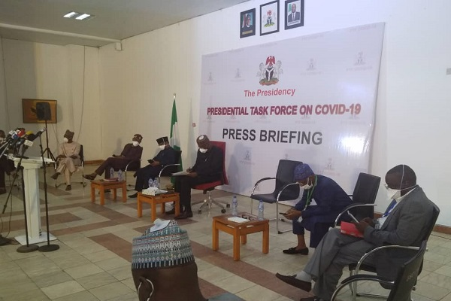
INDEPENDENT CORRUPT PRACTICES AND OTHER RELATED OFFENCES COMMISSION
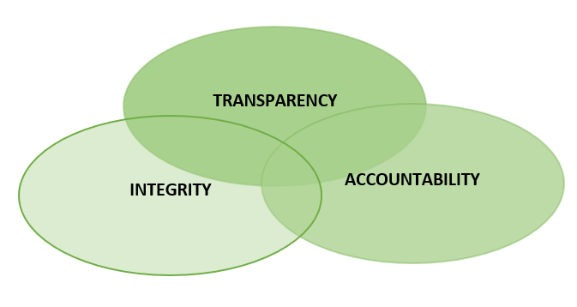
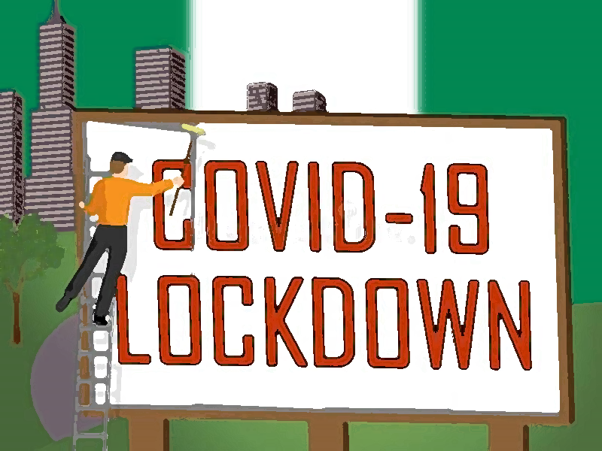

In the execution of its preventive mandate in Section 6 (b)-(d) of the Corrupt Practices and Other Related Offences Act, 2000, the Commission has set up an independent COVID-19 Funds Monitoring Team charged with the prevention of possible financial abuses that may arise in the management of the Covid-19 special intervention funds.
In collaboration with the Presidential Task Force (PTF) on COVID -19, the Team will monitor the disbursement and utilisation of the funds, donations and other receipts mobilised towards combating the outbreak of the Coronavirus in the country. In furtherance of this objective, this guideline have been developed to facilitate the various activities of the Task Force.
- Bank Accounts Policy
1. The Chairman of the Task Force (herein referred to as “Chairman”) may designate:
- Bank accounts in which funds and donations are paid into (note these are solely collection accounts), for control purposes;
- A specific bank account into which all receipts from the collections accounts are swept into at regular intervals and payments/expenditure are to be made from this account.
2. Two signatories are required on all withdrawal instruments including electronic mode of payment.
3. The signatories are to be appointed by the Chairman.
4. The signatories shall not have approving powers but should be responsible for the day to day operations of the bank accounts.
5. All correspondence from the banks must be directed to the Chairman.
6. A reconciliation of the bank accounts and books of accounts maintained shall be submitted to the Chairman every month.

- Cash Advances
1. Subject to the Financial Regulations (FR) and Pubic Service Rules (PSR), petty cash advances may be made to an officer for petty cash transactions as approved by the Chairman.
2. Officials who receive such advances shall be personally accountable and financially liable for the custody and management of the advances and must account for the advances at any given time. They are to report weekly to the Chairman or as he may direct.
- Expenditures/Payments

1. All payments to third parties such as vendors or suppliers and allowances to ad-hoc staff shall be by bank transfer, except where the Chairman approves cash disbursement due to exigency.
2. Vendors and suppliers will only be paid after they have supplied or rendered the services contracted to them.
3. All recipients of payments must issue a written receipt to the Committee stating amount and purpose.
4. All disbursements must be recorded in the books of accounts opened by the Task Force.
5. The Chairman shall be given a weekly update of inflows/receipts and outflows/expenditures.

- Authorizations
Approval thresholds will be as it is obtainable in the public service. The Chairman may consider limiting his approval threshold to that applicable to his office as the Secretary to the Government of the Federation. Any approval above this may be referred to the task force for consideration.

Where expenditure exceeds that of the office of the SGF requiring MTB approval, the PTF may play the role of MTB because of the emergency, thereafter the PTF should present the expenditure to Mr. President for ratification.

- Procurement

1. The Chairman shall be responsible for:
- The procurement function of the Task Force.
- Ensuring value for money, fairness, transparency
accountability and integrity, and the overall interest of the nation.
- Ensuring that all procurements are guided by the provisions of section 43, Public Procurement Act, 2007.
- Establishing a protocol or procedure for individual recipients of materials to sign and acknowledge receipt.
- Where the MDAs are to make the procurement, their Permanent Secretaries or Accounting Officers should follow the recommendations in addition to the provisions of the Public Procurement Act, 2007.
- Procurement post-Covid by any of the relevant MDAs must comply fully with the provisions of the Public Procurement Act, 2007 that apply to regular procurement of goods and services, the Permanent Secretaries’ Accounting Officers and members of Ministerial Tenders Board are to take full responsibility.

2. A sub-committee should be appointed and be responsible for receiving and issuance of materials procured during COVID-19 emergency response.

- Audit, Oversight, Monitoring and Evaluation

To ensure that the COVID-19 funds achieve their intended outcomes, the Task Force should also consider the following additional lines of actions:
1. Develop a mechanism for weekly reviews and evaluations of its administrative procedures to enable quick improvement of processes so as to mitigate corrupt tendencies.
2. Ensure that emergency response and disbursements are accompanied by well-structured auditing, oversight, accountability and reporting mechanisms so that resources get to those who are really in need.
3. The audit process should ensure that approvals of the Chairman or that of the Task Force are strictly adhered to, value for money is achieved and the objectives of the taskforce are met.
4. The Task Force should also engage the active participation of individuals or groups outside the public sector to enhance accountability, transparency and promote public participation and contribution. This would also ensure that the public has access to information and feedback on the emergency response to avoid suspicion of corruption.

- Exception
This Guideline will not apply to donations and receipts from the private sector, provided they are not given to the Task Force to manage.

Reference:
UNODC: Accountability and the Prevention of Corruption (2020)

Toll-free Lines: 0800 - 2255 – 4272
ICPC Nigeria (@icpc_pe)
ICPC Nigeria
ICPC Nigeria
ICPC Nigeria
info@icpc.gov.ng
http://www.icpc.gov.ng/

