REPORT OF THE EDUCATIONAL EXCURSION OF MEMBERS OF THE STUDENTS ANTI-CORRUPTION CLUB OF GOVERNMENT SECONDARY SCHOOL KUBWA ON 14th JUNE 2016.

INTRODUCTION
In continuation of its drive to ensure active youth participation in the fight against corruption the Commission hosted members of the Students Anti-corruption Club of Government Secondary School, Kubwa who visited its headquarters on an educational excursion. The event was a fall out of the recent project of the Education Department: “Rejuvenation of Clubs” aimed at reviving the Clubs so that they can be vibrant thereby contributing effectively to tackle corruption in the schools. Other objectives of the programme include:
- To inculcate into the students the tenets of fighting corruption from personal to the general level.
- To strengthen and give them, the foot soldiers, a sense of belonging
- To bring to their knowledge the whole concept of ICPC and the journey so far.
The event which was held at the Integrity Kitchen attracted six major media houses (electronic and print) in the country as well as senior officers of Education and Public Enlightenment Departments.

EXECUTION
The programme started with an opening remark by the HOD Education Mr. G. T Anumve who represented the Chairman of the Commission Barr. Ekpo Nta. He on the behalf of the Chairman welcomed all that were present and thanked the matron, executives and members of the Students Anti-Corruption Club (SAC) of Government Secondary School, Kubwa for coming to ICPC on Educational excursion. In his remarks, he highlighted the three core mandates of the ICPC: Enforcement; Prevention; Public Education and Mobilization and emphasized that it is through education and mobilization activities that ICPC educate students, Civil Society Organisations, Ministries, Department and Agencies, Youth Corps members, and all sectors of the society on the dangers of corruption to the society. According to him the Commission places a high value to occasions like this. He concluded by encouraging the students to desist from all forms of corruption so as to stand against it effectively.
In her response, the Matron of the SAC, Mrs. Stella Nwokorie narrated how the Club was rejuvenated in May 2016 through the persistent follow ups by Miss Nma Ude and Mr. Michael Atodo of Education Department. She reminded her students that they are the future leaders and appealed to ICPC to continue to partner with the School as well as the Club in the fight against corruption.
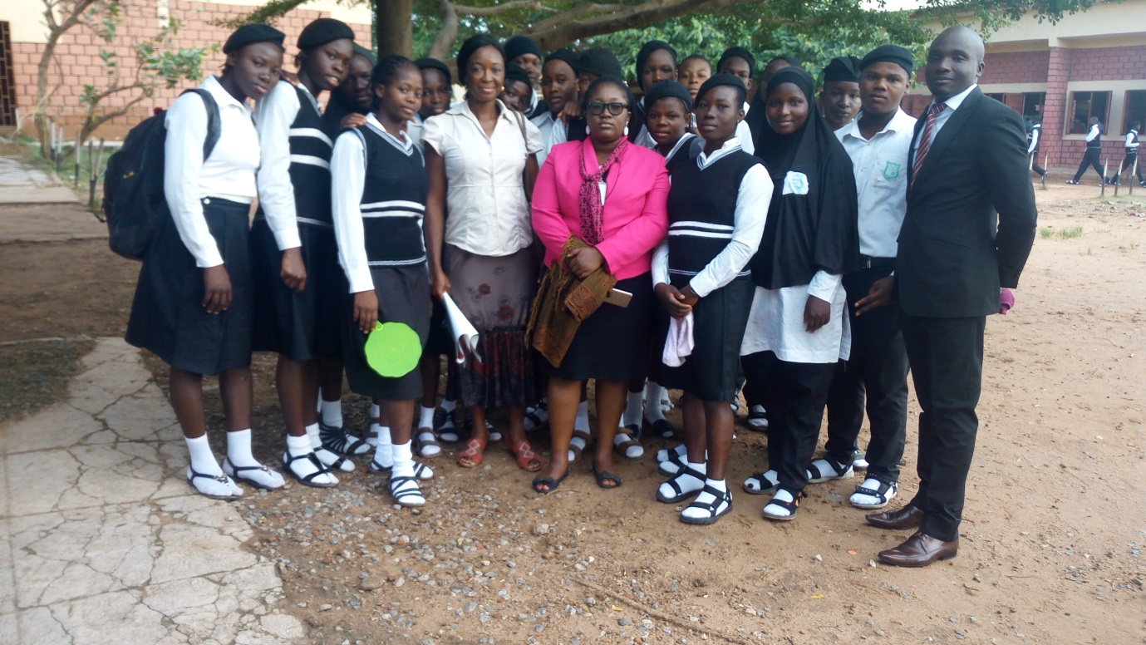
Miss Nma Ude and Mr. Micheal Atodo (officers of ICPC) pose with the Matron and members of the Club during a visit to the school

POWER POINT PRESENTATION
In a Power- Point Presentation titled ‘About ICPC’ Mrs Azuka Ogugua of Education Department, highlighted the Mission, Vision and Mandate of ICPC. She enumerated some of the Corrupt Practices among Youths which include examination malpractice, falsification of Certificate, Reports and records, sex for marks among others. She further stated that the Commission developed the National Values Curriculum (NVC) for the Youths and infused the topics into the Education Curriculum. She itemised and explained the Core Values in the National Values Curriculum namely: Traditional Values, Honesty, Discipline, Justice, Right Attitude to Work, Citizens Rights and Duties, National Consciousness, Contentment, Courage, Concern for Others, Family Values and religious values. In addition, she enumerated some of the Commission’s Youth Integrity Programmes which include: Integrity Lecture Series, Youth Competitions, Youth Integrity Camp, NYSC Lecture series and Community Development Service (CDS) group coordination.
In Conclusion she mentioned some of the things Students can do to fight Corruption which include:
- Imbibing the spirit of Integrity, honesty, Punctuality, Decency and Diligence.
- Being a committed member of the Students Anti-Corruption Club (SAC) and declare your School Corruption free zone
The interactive session that ensued featured intelligent questions that bordered on whistle blower protection; how to report corrupt acts, identified corrupt acts within the system, core activities of the club within the school environment. These and more were effectively addressed by HOD and senior officers of the Education department.

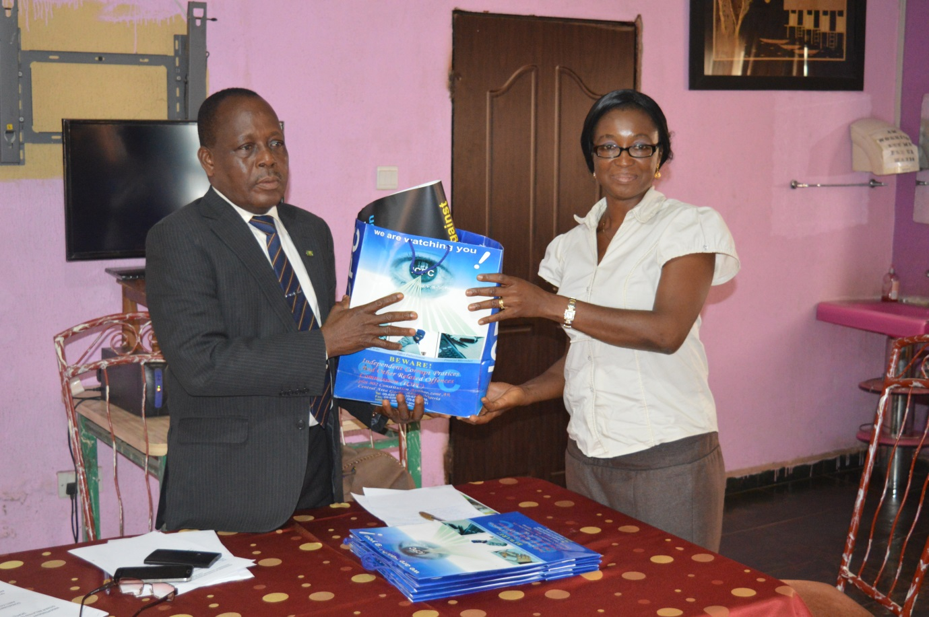
HOD Education, Mr. G T Anumve presenting IEC materials to the Matron Mrs. Stella Nwokorie
In the course of the event Information Education and Communication (IEC) materials were handed out to the Matron of the Club. The Club members were taken on a tour of the ICPC Cell and recovered vehicles / properties within the Commission.

The excursion ended with a vote of thanks by the President of the Club, Master Yahaya Shuaibu who thanked the Commission for granting them audience and appealed for a continued and stronger partnership between the ICPC and the Club.
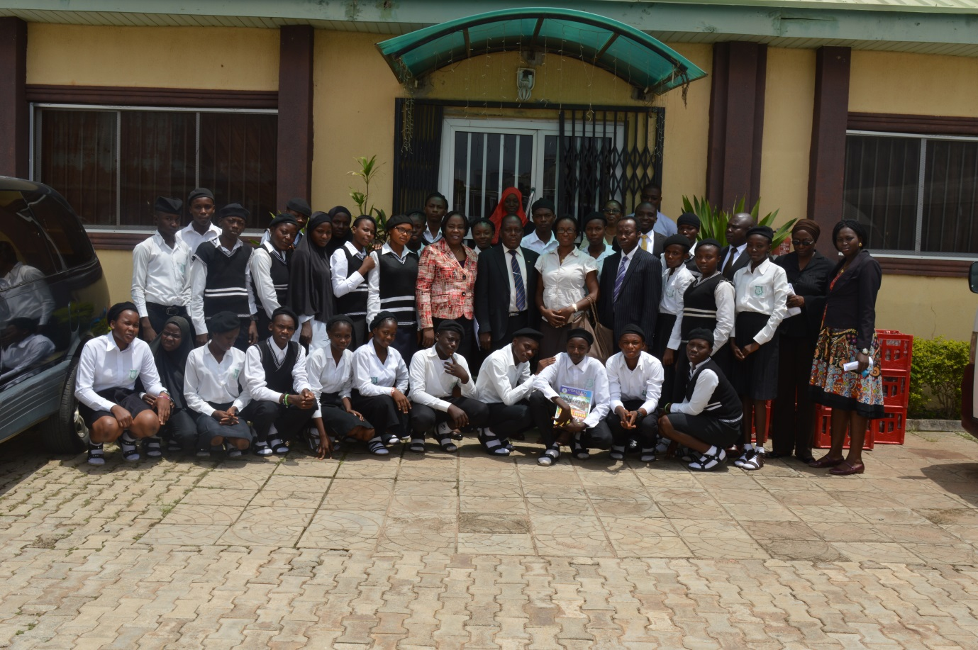
HOD Education and senior officers of Education and Public Enlightenment department pose with matron and members of the SAC

RECOMMENDATION
It was recommended that more rejuvenation activities and interactions be made by officers with schools were the SAC exists to enhance the anti-corruption campaign among the youths and within the education sector.

K. C OBI
HEAD OF UNIT
YOUTH EDUCATION AND MOBILIZATION
EDUCATION DEPARTMENT

